|  |  |
| --- | --- |
| BỘ GIÁO DỤC ĐÀO TẠO  **TRƯỜNG ĐẠI HỌC CÔNG NGHỆ ĐÔNG Á**    Khoa Ngôn ngữ Anh | **CỘNG HÒA XÃ HỘI CHỦ NGHĨA VIỆT NAM**  **Độc lập - Tự do - Hạnh phúc**  *Bắc Ninh, ngày tháng năm 2023* |

**NGÂN HÀNG CÂU HỎI THI KẾT THÚC HỌC PHẦN**

Tên học phần: Tiếng anh 2 số ĐVHT: 3TC

Hệ đào tạo: Đại học chính quy

**Contents**

**Task 1(Vocabulary): 1**

**Task 2 (Grammar) 28**

**Task 3: Reading comprehension 46**

**Task 4: Text completion 73**

**Task 5: listening 86**

**Task 6: listening 118**

**Task 7: Rearrange 123**

**Task 8: Error correction 136**

# **Task 1(Vocabulary):**

Choose the best answer to complete the sentences (chọn đáp án đúng nhất để hoàn thành câu) (100 câu)

1. ::CHO1:: For a ______ of reasons, he wouldn’t accept our offer.

{

~ variation

~ variety

~ variant

~ varying

}

::CHO2:: Wholesale and _______ sales registered negative growth last month.

{

~ part

~ division

~ retail

~ gross

}

::CHO3:: In the 1930s, there was a world-wide economic _____ and mass.

{

~ policy

~ prosperity

~ activity

~ depression

}

1. ::CHO4:: The client agrees to pay all hotel ______on due dates.

{

~ fines

~ tuitions

~ fares

~ charges

}

::CHO5:: Our basic_______ is that the customer is always right.

{

~ policy

~ expertise

~ profession

~ specialty

}

1. ::CHO6:: When does the _______ for your printer expire?

{

~ certificate

~ warranty

~ license

~ approval

}

::CHO7:: Other documents are available upon______.

{

~ need

~ want

~ necessity

~ request

}

::CHO8:: The new law takes_____ next week.

{

~ outcome

~ result

~ consequence

~ effect

}

::CHO9:: ______ must be paid to what’s going on here.

{

~ attention

~ looking

~ presence

~ attendance

}

1. ::CH10:: Prior to leaving, check your bank ____.

{

~ change

~ balance

~ remains

~ rest

}

::CH11:: His wedding has been _______ in the newspapers.

{

~ said

~ told

~ pronounced

~ announced

}

1. ::CH12:: I was ______ for speeding.

{

~ find

~ found

~ fined

~ founded

}

::CH13:: I asked them to ________ the cost of repairing my car.

{

~ cost

~ evaluate

~ estimate

~ predict

}

::CH14:: I wonder if you could _______ a room for me at the hotel.

{

~ make

~ reserve

~ do

~ preserve

}

::CH15:: Let’s not_______ from the point at issue.

{

~ avoid

~ digress

~ refuse

~ subtract

}

;:CHI6:. I never see him without being ……………. of his grandfather.

{

~ remember

~ memory

~ remained

~ reminded

}

::CH17:: Left alone, the baby ……………. into tears.

{

~ cried

~ poured

~ burst

~ sobbed

}

::CH18:: He _______ a favor of me.

{

~ told

~ talked

~ asked

~ inquired

}

1. ::CH19:: If you violate any conditions specified there in, the contract will automatically _______.

{

~ complete

~ terminate

~ annul

~ abolish

}

1. ::CH20:: I’d like to _______ my check.

{

~ cash

~ charge

~ bill

~ exchange

}

1. ::CH21:: Can I ______ money online to Brazil?

{

~ refund

~ transfer

~ reimburse

~ repay

}

1. ::CH22:: The United States is waging a _______ war overseas.

{

~ cost-free

~ costly

~ costless

~ money

}

::CH23:: There is no ______ evidence that power lines are a health risk.

{

~ conclusive

~ final

~ last

~ finishing

}

::CH24:: He works in the ______ division of our company.

{

~ personal

~ personnel

~ individual

~ impersonal

}

::CH25:: This is not ______ business; it can wait.

{

~ tiring

~ taxing

~ urgent

~ demanding

}

::CH26:: Our team is _______ to win this time.

{

~ like

~ alike

~ likely

~ probably

}

::CH27:: They’ve arranged a _______ reception for us.

{

~ heating

~ hospital

~ warm

~ hospitably

}

::CH28:: ______ after his arrival in Paris, Tom called me at the office.

{

~ Briefly

~ Nearly

~ Shortly

~ Simply

}

::CH29:: Last year, the shoe company ______ went bankrupt.

{

~ all

~ nearly

~ mostly

~ next to

}

1. ::CH30:: Meetings will be broadcast _____ a week after they take place. {

~ substantially

~ potentially

~ comparatively

~ approximately

}

::CH31:: I’m ______. Would you lend me some money?

{

~ borrow

~ rich

~ poor

~ broke

}

::CH32:: Madeline must be very tired; she is ______ on the sofa.

{

~ jumping

~ lying

~ awake

~ cleaning

}

::CH33:: Mike didn’t _____ at Jill’s party last night because he had a headache.

{

~ show up

~ come up

~ make up

~ hang up

}

::CH34:: We________ to inform you that the position has been filled.

{

~ sorry

~ apology

~ regret

~ apologize

}

::CH35:: He ____ decided to quit his job and look for another one.

{

~ finally

~ belated

~ last

~ delayed

}

::CH36:: She ______ to giving up her project.

{

~ objected

~ protested

~ complained

~ suggested

}

::CH37:: The secretary was working _______ that night.

{

~ overwork

~ extra work

~ overtime

~ overhours

}

::CH38:: He has his shoes _______ everyday.

{

~ shined

~ put on

~ made

~ bought

}

::CH39:: Extremely ______ from the hard work, he couldn’t walk an inch.

{

~ busy

~ excited

~ exhausted

~ happy

}

::CH40:: Who is that man _______ the red jacket?

{

~ wearing

~ having

~ doing

~ inside of

}

::CH41:: “Didn’t you ______ the exam?” “No, I did not”.

{

~ succeed

~ success

~ pass

~ graduate

}

::CH42:: Let’s _______ the art gallery first, and then have some lunch.

{

~ trip

~ journey

~ visit

~ turn up

}

::CH43:: The weather couldn’t be ______; it’s perfect.

{

~ better

~ colder

~ hotter

~ summer

}

::CH44:: Professor Miller requires that all papers be _____ in ink.

{

~ formatted

~ copied

~ written

~ made

}

::CH45:: The couple must need a ______ because they have just returned from a long journey.

{

~ rest

~ pause

~ stop

~ discontinuation

}

::CH46:: Johnny continued to make ______, though he was told not to.

{

~ noisy

~ sounded

~ noise

~ loud

}

::CH47:: If you would like to be considered for a position in our advertising division, please ______ an application to the director of human resources.

{

~ submit

~ comply

~ advise

~ urge

}

::CH48:: Lan doesn’t talk much in public. She’s rather _________ in public.

{

~ silent

~ reserved

~ talkative

~ impolite

}

::CH49:: Customers unhappy with the performance of their stereo equipment have two months to request a refund or ____.

~ replace

~ replaced

~ replacement

~ replacing

}

::CH50:: The jacket you ordered is currently_______ in the color you requested, but we will send the rest of your order promptly.

{

~ related

~ unavailable

~ disinterested

~ stylish

}

::CH51:: Your sales report is very……….

{

~ interested

~ interesting

~ interest

~ meeting

}

::CH52:: He’s a very…………person.

{

~ society

~ sociable

~ sociably

~ socially

}

::CH53:: I found the ……. useful.

{

~ discussion

~ discuss

~ discussing

~ discussed

}

::CH54:: The engineer made his colleagues an …….device.

{

~ effectively

~ effection

~ effect

~ effective

}

::CH55:: He made the company…..

{

~ profitable

~ profit

~ profited

~ profitably

}

::CH56:: The employee in the Accounting Department found the job…..

{

~ impossibly

~ impossibility

~ impossible

~ possibility

}

::CH57:: He ..... his job 2 months ago.

{

~ broke

~ gave

~ quit

~ leaved

}

::CH58:: They’ve already..... from a business trip.

{

~ back

~ returned

~ home

~ away

}

::CH59:: She managed to ........the office for help as she got a traffic jam.

{

~ contact

~ get

~ announce

~ promote

}

::CH 60:: Mr Bean highly.......this item to his employees.

{

~ repairs

~ does

~ completes

~ recommends

}

::CH 61:: Sally burned the midnight oil to ..... a project.

{

~ repair

~ do

~ complete

~ recommend

}

::CH 62:: The new printer is as ………. as the old one.

{

~ effective

~ effectively

~ affection

~ effect

}

::CH 63:: They are as …….as Mr. Armstrong for this work.

{

~ qualify

~ qualified

~ qualification

~ qualifies

}

::CH 64:: Fabrics from Harmia Textiles are known for their vibrant.......

{

~ colors

~ colored

~ colorful

~ colorfully

}

::CH 65:: Because of roadwork, Ms. Kim’s drive to the office may..... longer than usual.

{

~ move

~ act

~ take

~ do

}

::CH 66:: Fortunately, Anna had ...... me of the meeting, so I didn’t miss it.

{

~ accounted

~ concentrated

~ filled

~ reminded

}

::CH 67:: He suffered from a serious illness, then he quickly ......over it.

{

~ commented

~ got

~ informed

~ took

}

::CH 68:: To ..........on the lessons, you should keep off your cell phones.

{

~ concentrate

~ take advantage

~ remind

~ inform

}

::CH 69:: I’m …… forward to seeing you soon.

{

~ preventing

~ working

~ doing

~ looking

}

::CH 70:: Susan managed to ......with her problem herself.

{

~ take

~ deal

~ apologize

~ provide

}

::CH 71:: It’s very polite of him to ......for being late.

{

~ apologize

~ take

~ remind

~ get

}

::CH 72:: Mr Lee was asked to ..... a survey last week.

{

~ cause

~ conduct

~ meet

~ seek

}

::CH 73:: Being a team leader, Mr Kim took responsibility for...... a conference.

{

~ notifying

~ discontinuing

~ holding

~ causing

}

::CH 74:: He is determined to …… from the government.

{

~ stop

~ quit

~ free

~ resign

}

::CH 75:: Susan often …….her car to school last semester.

{

~ drove

~ got on

~ went with

~ rode

}

::CH 76:: The television ….. me when I study.

{

~ pays

~ distracts

~ focuses

~ pulls

}

::CH 77:: …..three copies of this letter, please.

{

~ Make

~ Be

~ Do

~ Build

}

::CH 78:: The pencil needs to be ……..

{

~ made

~ used

~ sharpened

~ pointed

}

::CH 79:: A...…. amount of money has been spent on books.

{

~ considerate

~ considerable

~ considered

~ considering

}

::CH 80:: Mr. Kim’s ……was confusing, and some concepts were difficult to understand.

{

~ suggested

~ suggesting

~ suggests

~ suggestion

}

::CH 81:: Given big bonuses last week, all the ……….. seemed pleased.

{

~ employees

~ employment

~ employee

~ employed

}

::CH 82:: You should prepare the contract in……

{

~ schedule

~ copyright

~ duplicate

~ charge

}

::CH 83:: Retail properties in the downtown area generally stay on the ______ for periods of three to six weeks before they are sold.

{

~ sale

~ market

~ place

~ advertisement

}

::CH 84:: My father is ……. me to bring whomever I wish.

{

~ making

~ allowing

~ letting

~ giving

}

::CH 85:: Patients who wish to reschedule their ….... must give at least 24 hours advance notice.

{

~ appointment

~ position

~ assignment

~ problem

}

::CH 86:: During the exam, students are …….. from talking to one another.

{

~ allowed

~ prohibited

~ made to stop

~ halted  
}

::CH 87:: It’s very kind of him to …… homeless people with a lot of food.

{

~ get

~ give

~ provide

~ cause

}

::CH 88:: The new graphic design software program has improved the quality of the designer’s work as well as their ….....

{

~ harvest

~ measures

~ promotion

~ productivity

}

::CH 89:: The fax machine is out of service, and an experienced ……. has been called in to see if it can be repaired.

{

~ technician

~ factory

~ certificate

~ generator

}

::CH 90:: I will…….you of the changes as soon as I get them.

{

~ seek

~ notify

~ resume

~ discontinue

}

::CH 91:: Tower Apartments plans to add a recreation complex that will accommodate a swimming pool and other……..

{

~ facilities

~ qualities

~ conventions

~ categories

}

::CH 92:: Please check in with Ms. Nakamura’s assistant when you arrive so he can …….her of your arrival.

{

~ speak

~ notify

~ report

~ attend

}

::CH 93:: Mr. Ortega has received an ………..to attend the awards ceremony in Brussels next month.

{

~ honor

~ prize

~ expression

~ invitation

}

::CH 94:: The new science museum is expected to …….. many tourists to the city.

{

~ attract

~ value

~ observe

~ prohibit

}

::CH 95:: To take …… of the company’s free software-upgrade program, customers should mail a copy of their receipt to the address provided.

{

~ merit

~ advantage

~ service

~ improvement

}

::CH 96:: Once you have placed your ……, its status will be available on our Web site.

{

~ order

~ value

~ refund

~ sale

}

::CH 97:: The town council of Santa Rosa will ……. tomorrow to discuss a new zoning plan or the commercial district.

{

~ obtain

~ review

~ meet

~ appoint

}

::CH98:: Fujimori Builders will put up signs directing traffic in order to …. for road construction in the area.

{

~ restore

~ predict

~ initiate

~ prepare

}

::CH99:: Tedeschi Shoes ….. a discount to students of Brinkley University.

{

~ seems

~ pleases

~ meets

~ offers

}

::CH100:: Mr Park will retire at the end of the month, and Mr Lee will assume the …….of the company vice president.

{

~ role

~ portion

~ use

~ example

}

# **Task 2 (Grammar)**

*Choose the best answer to complete the sentences (chọn đáp án đúng nhất để hoàn thành câu) (100 câu)*

1. Either Sam Tom will be sent to the new branch in L.A.

A. and B. or C. but D. nor

2. He didn’t like his job, he quit three months ago.

A. yet B. or C. but D. so

3. I don't know _________ he has enough money to invest in the stock market.

A. but B. and C. if D. because

4. My dream is I start to run my own-business.

A. whether B. that C. so D. but

5. _______ you sign the contract, you should read it carefully.

A. Once B. After C. Unless D. Before

6. You will not get paid you are on time.

A. as long as B. when C. if D. unless

7. ______ they bought a new machine, the sales decreased.

A. Because B. Even C. Although D. So

8. I will make a copy of the proposal _____ that you can take it.

A. such B. so C. even D. because

9. I bought an umbrella __________ it was raining.

A. so B. because C. also D. why

10. ________ you were a member, you could come too.

A. That B. If C. Than D. So

11. ______ I was clean, I took a bath.

A. What B. As long as C. Such D. Even though

12. While ______ my new book, I learned something interesting.

A. to read B. read C. to reading D. reading

13. ______ he was boarding the bus, he dropped his ticket in the gutter.

A. Whether B. How C. While D. What

14. You can either rent ______ buy these skateboards.

A. or B. and C. nor D. either

15. I neither registered for __________ attended the class.

A. or B. nor C. either D. neither

16. You have to pay a deposit 30 days.

A. by B. until C. at D. within

17. The annual sales meeting will be held noon.

A. in B. at C. on D. for

18. The executive officers walked the corridor.

A. along B. among C. within D. over

19. The train Philadelphia will leave in five minutes.

A. over B. for C. between D. along

20. We were surprised ______ the news report.

A. in B. for C. at D. as

21. She is a very ________person. Everyone loves her ideas.

A. creative B. created C. creativity D. creating

22. Ten countries, ______ England, joined the organization.

A. included B. including C. include D. includes

23. _____the bad situation, he successfully finished the job.

A. Because B. In spite of C. Although D. Despite of

24. If you have any problems the service, just let me know.

A. regardless B. regard

C. regarding D. regarded

25. Thank you _________ your inquiry about our products.

A. To B. as C. Of D. for

26. ________ he has a lot of experience, he was able to get a job easily.

A. Even though B. Because C. Due to D. In spite of

27. The team members had a discussion the advertisement.

A. to B. with C. about D. from

28. You can get a full refund 30 days of purchase.

A. to B. within C. for D. as

29. The applicants have to wait next week for the results.

A. until B. by C. despite D. at

30. _________ the machine is extremely expensive, our company can’t afford it.

A. Because of B. Since C. Owing to D. Also

31. The editing must be completed by next Monday the latest

A. on B. of C. in D. at

32. Please explain the current situation detail.

A. in B. for C. on D. of

33. You should prepare the contract duplicate.

A. with B. on C. in D. for

34. Going on a business trip three times a month too frequent.

A were B be C are D is

35. The displayed furniture not for sale.

A have B has C is D are

36. He said that competent managers _ their employees.

A. helping B. help C. to help D. helps

37. The CEO announced that sales _ for three years.

A. falls B. fall C. had fallen D. have fallen

38. The article that the population of the world is increasing.

A. saying B. says C. say D. is said

39. Both of the applicants scheduled for an interview today.

A. are B. being C. is D. was

40. The president and the vice president in the conference room.

A. are B. being C. is D. was

41. Every country interested in the global trade issue.

A. have B. are C. is D. has

42. The number of online shopping malls _ _ increasing.

A. is B. are C. to be D. being

43. Some of the luggage stolen at the airport.

A. has B. are C. was D. were

44. The good news that I will get a pay raise.

A. have B. were C. are D. is

45. Most of the interviewees very punctual.

A. is B. are C. to be D. being

46. The sales meeting place in the auditorium every two months.

A. is taking B. is taken C. take D. takes

47. Tim Scott, the founder and CEO of the company, _ in 2000.

A. died B. die C. is dying D. is died

48. Fortunately, neither the driver nor the passengers _ injured.

A. had B. has C. was D. were

49. The prime minister was in a bribe scandal.

A. involve B. involved C. be involved D. be involving

50. This cellular phone is superior the competitors in quality.

A. for B. to C. on D. than

::CH51:: The man ….……….. the marketing manager.

{

~ is

~ he

~ very

~ it

}

::CH52:: Your sales report is very ….………..

{

~ them

~ meeting

~ interest

~ interesting

}

::CH53:: The new employee ……………. near the office.

{

~ he

~ him

~ living

~ lives

}

::CH54:: The strategy meeting .……………. in an hour.

{

~ they

~ in the room

~ it

~ starts

}

::CH55:: Mr. Kim’s suggestion about the problem ………….. practical.

{

~ seemed

~ they

~ very

~ useful

}

::CH56:: The relocation of the office wasn’t …………… at first.

{

~ easily

~ easy

~ seemed

~ became

}

::CH57:: TeleCom ……………. cellular phones at low prices.

{

~ its

~ us

~ selling

~ sells

}

::CH58:: He ……………. the company profitable.

{

~ looked

~ was

~ seemed

~ made

}

::CH59:: The employee in the Accounting Department ……………. the job impossible.

{

~ found

~ seemed

~ worked

~ became

}

::CH60:: This is the ………… hotel available in this district.

{

~ good

~ best

~ more good

~ better

}

::CH61:: Which is the ……………. month of the year in your country?

{

~ most hot

~ many more hotter

~ much hot

~ hottest

}

::CH62:: Yesterday’s game was ……… in this series.

{

~ more exciting

~ the most excited

~ the most exciting

~ more excited

}

::CH63:: The longer you practice, ………….. accurately you will be able to type.

{

~ the

~ the most

~ the more

~ more

}

::CH64:: She tried to express her feelings ……… she could.

{

~ more honest than

~ as honestly as

~ as honest as

~ more honestly

}

::CH65:: Of the three runners, she is by far ………….. .

{

~ a runner

~ the fastest

~ very slow

~ very fast

}

::CH66:: Jerry had ………….. difficulty of all the students in figuring out the problem.

{

~ a lot of

~ some

~ fewest

~ the least

}

::CH67:: This box is …………. as that one.

{

~ boxier

~ filled with toys

~ twice as large

~ a square

}

::CH68:: This is much ……….. than expected.

{

~ well

~ good

~ better

~ best

}

::CH69:: This lake is much ……….. than the one near my house.

{

~ deep

~ deeper

~ deeply

~ deepness

}

::CH70:: Her granddaughter is as tall ……………. a high school student.

{

~ as

~ than

~ for

~ of

}

:CH71:: The purpose of the meeting is ……………… the issue.

{

~ discussion

~ to discuss

~ discuss

~ discussed

}

::CH72:: Mr. Kim worked hard …………. a promotion.

{

~ getting

~ to get

~ got

~ get

}

::CH73:: This place is quiet enough for the staff ………….. on the project.

{

~ to work

~ work

~ works

~ worked

}

::CH74:: This year's sales target was too high for us …………….

{

~ achieve

~ to achieve

~ achieving

~ to be achieved

}

::CH75:: We are eager …………………… you and to talk about the issue.

{

~ meet

~ meeting

~ to meet

~ met

}

::CH76:: Her job is ………………. phone calls from customers.

{

~ answered

~ answer

~ answering

~ to answering

}

::CH77:: They postponed ……………….. a new branch in San Diego.

{

~ opening

~ open

~ to open

~ opened

}

::CH78:: The team is busy ……………….. a new software program.

{

~ develop

~ to develop

~ developing

~ development

}

::CH79:: We would like to thank you for ……… in our annual conference.

{

~ participate

~ participating

~ participated

~ to participate

}

::CH80:: Mr. Carter has had difficulty ……………. experienced research specialists since last month.

{

~ find

~ to find

~ found

~ finding

}

::CH81:: We are looking for ……………..workers.

{

~ experience

~ experiences

~ experiencing

~ experienced

}

::CH82:: …………… from the USA, some books were seriously damaged.

{

~ Delivery

~ Delivered

~ Deliver

~ Being delivering

}

::CH83:: Before ………..…. on vacation, you should report it to the manager.

{

~ going

~ go

~ gone

~ went

}

::CH84:: She was …………...

{

~ surprise

~ to surprise

~ surprised

~ surprisingly

}

::CH85:: …………… from a distance, the painting appeared quite realistic.

{

~ Seen

~ Saw

~ Seeing

~ See it

}

::CH86:: There’s ……………. news.

{

~ exciting

~ excite

~ excitement

~ excited

}

::CH87:: Anyone ………………… in working abroad should talk to a supervisor.

{

~ interest

~ interests

~ interested

~ interesting

}

::CH88:: They saw a group of people ……………… the mayor’s office.

{

~ entering

~ entered

~ to enter

~ entrance

}

::CH89:: ……………… big bonuses last week, all the employees seemed pleased.

{

~ Giving

~ Give

~ Given

~ To give

}

::CH90:: Mr. Kim’s suggestion was …………… ., and some concepts were difficult to understand.

{

~ confusing

~ confuses

~ confuse

~ confused

}

::CH91:: I don’t think many people will have a chance ……………… for the job.

{

~ for applying

~ applying

~ to apply

~ to applying

}

::CH92:: All the employees were asked ……………… the meeting on Saturday.

{

~ attend

~ attended

~ to attend

~ attending

}

::CH93:: The mummy is the ….…………… object in the museum.

{

~ most interesting

~ interesting

~ boring

~ more interesting

}

::CH94:: Misung swims ………..… than Mia, but Mia can swim farther.

{

~ fast

~ fastest

~ faster

~ too fast

}

::CH95:: Brian is a lot ……………….. than George.

{

~ taller

~ tall

~ more taller

~ the taller

}

::CH96:: Many employees in the office are interested in ………… medical checkups.

{

~ get

~ to get

~ getting

~ gotten

}

::CH97:: The newly hired secretary is good at ………………

{

~ organizing

~ to organize

~ organize

~ organization

}

::CH98:: ……………… in Spanish, the report is hard to understand.

{

~ Write

~ Writing

~ Written

~ To write

}

::CH99:: Please post the …………… information on the bulletin board.

{

~ requested

~ request

~ requesting

~ to request

}

::CH100:: The participants at the book fair seemed quite …………….…..

{

~ satisfaction

~ satisfied

~ satisfying

~ satisfy

}

# **Task 3: Reading comprehension**

READING COMPREHENSION

Directions: In this part you will read a selection of texts. Each text is followed by several questions. Select the best answer for each question and mark the letter A, B, C, or D on your answer sheet.

Questions 1-3 refer to the following advertisement.

Marketing Director

The Dooris Company is one of the best computer manufacturing companies in the world. We are now looking for an excellent marketing director.

Responsibilities:

- Manage the marketing budget

- Develop effective marketing strategies

Requirements:

- A minimum of 5 years of experience preferred

- Excellent written and oral communication skills

- Bilingual (English, Spanish) required

Applicants should send a résumé and cover letter by March 1.

1. What is the purpose of this advertisement?

(A) To reduce the marketing budget

(B) To encourage employees to work harder

(C) To report on marketing strategies

(D) To hire an employee

2. What is NOT a requirement for the position?

(A) A minimum of 5 years of experience

(B) Accounting experience

(C) Strong communication skills

(D) The ability to use English and Spanish

3. How many experience years are required for this position?

(A) At least 5 years

(B) Nearly 5 years

(C) More than 5 years

(D) Less than 5 years

Questions 4-5 refer to the following advertisement.



4. What is the purpose of this advertisement?

(A) To provide scholarships for adults

(B) To inform adult learners of the importance of learning

(C) To talk about educational opportunities for adults

(D) To give tips on how to get a higher degree

5. Where can one find further information on this education program?

(A) In a newspaper

(B) On the Internet

(C) On a board

(D) In a magazine

Questions 6-7 refer to the following advertisement.



6. What is the purpose of this advertisement?

(A) To look for a manager

(B) To promote a new store in San Diego

(C) To hire a secretary

(D) To announce a manager's retirement

7. Which of the following is NOT true about the advertisement?

(A) Scope City is an optics store.

(B) The manager's job is in San Diego.

(C) One can apply for the job by visiting the store.

(D) Managerial experience is necessary for the job.

Questions 8-9 refer to the following letter.

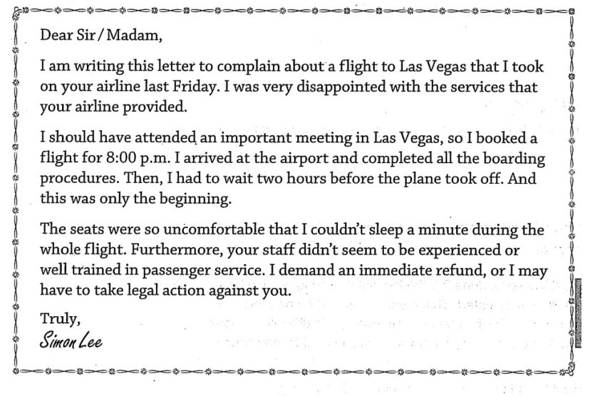

8. What is the purpose of this letter?

(A) To make a reservation for a ticket

(B) To make suggestions about passenger service

(C) To request a full refund for the flight

(D) To ask for more information about the flight

9. What can be inferred about the 8:00 p.m. flight?

(A) It lacked food.

(B) It was cancelled.

(C) It was delayed.

(D) It was full of passengers.

Question 10-11 refer to the following letter.

Dear Sir/Madam,

I am writing to reply to your advertisement for a helper at one of your summer youth camps. I am very interested in the job, and I think I have the necessary qualifications because I have already worked as a sports instructor at many camps. I would be grateful if you could give me some more information about the job.

10. The word "grateful" in line 5 is closest in meaning to

A. helpful

B. thankful

C. meaningful

D. kind

11. What was the previous job of the writer?

A. A sports referee

B. A sports player

C. A sports instructor

D. A helper

Questions 12-13 refer to the following letter.

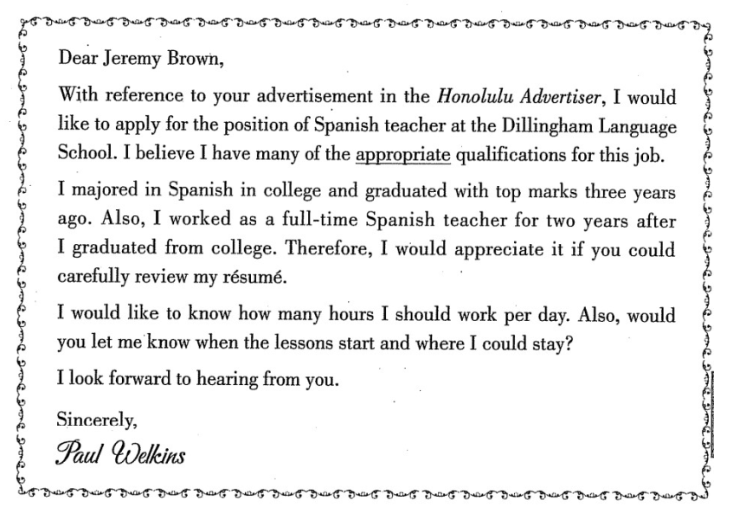

12. What is the purpose of the letter?

(A) To apply for a job

(B) To arrange an interview

(C) To accept a job offer

(D) To complain about some service

13. The word "appropriate" in paragraph 1, line 3 is closest in meaning to

(A) difficult

(B) unknown

(C) manageable

(D) suitable

Questions 14-16 refer to the following e-mail.

From: Su Jung Ahn <sujungahn@wanfile.co.kr>

To: Jill Webber <j.webber@halamail.co.au>

Subject: Respond

Date: May 30

Dear Ms. Webber,

Thank you for contacting us here at the Daejeon Family Inn. We would be happy to provide you with accommodations during your stay in Daejeon next month. Unfortunately, we do not have any rooms at our inn that operate as suites. However, we can book your family in two rooms that are at the end of a hallway, separate from the rest of the rooms at the inn. The two rooms are right next to each other, and you would have some privacy away from the other guests. Each room has its own bathroom with a shower and a queen-size bed. We hope they will be suitable for your needs.

If that will be to your satisfaction, we will book you in these two rooms for four nights beginning on June 26. These rooms are $30 per night. This price includes breakfast. Would you like to proceed with this reservation? If I can be of further assistance, please let me know.

Sincerely,

Su Jung Ahn

Manager, Daejeon Family Inn

14. Why was the e-mail written?

(A) To request information about an inn

(B) To provide confirmation of a reservation

(C) To give information about accommodation

(D) To confirm details of an upcoming trip

15. What is mentioned about the Daejeon Family Inn?

(A) It is owned by Su Jung Ahn.

(B) It provides shared public bathrooms.

(C) Its suites are already booked.

(D) It serves breakfast to guests.

16. The word "unfortunately" in line 2 is closest in meaning to

A. unhappily

B. unluckily

C. unclear

D. unhealthy

Question 17-18 refer to the following notice.

From the Offices of

Doctor Calvin Hoffman

27 Shilling Road ・ Canton, IL 61 520

(309) 555-0128

Because your health is important to us, we would like to remind you that it’s time for your examination. We look forward to seeing you!

Please call today to schedule an appointment.

Your appointment is on Monday, September 8 at 8:30 A.M.

Note: If you cannot keep your appointment, please provide at least 24 hours advance notice or you will be charged a fee.

17. Why was the notice sent?

(A) To advertise a doctor's services

(B) To cancel a meeting

(C) To remind a patient about an appointment

(D) To inform a doctor of a telephone call

18. What is mentioned about the doctor’s office?

(A) It has openings for new patients.

(B) It charges a fee for late cancellations.

(C) It is no longer open on Mondays.

(D) It calls people 24 hours before their visit.

Questions 19-20 refer to the following advertisement.

Flyte Bakery

All baked goods are handmade on the premises including

• Cakes

• Seasonal fruit pies

• Breads and pastries

• Cookies

• Personalized desserts for anniversaries, weddings, birthdays, and other special

occasions (Please order at least one week beforehand.)

Catering for corporate events and private parties is now available! To learn more about our rates, telephone us during the business hours below.

Monday - Saturday； 6 A.M. ~ 7 P.M., Sunday: 6A.M. -6 P.M.

Location: 192 South Street, Sydney

Tel: (02) 9272-6555

19. What item would need to be ordered in advance?

(A) An autumn harvest apple pie

(B) A personalized birthday cake

(C) Whole wheat bread

(D) Chocolate chip cookies

20. For what information are customers directed to call the bakery?

(A) Store hours

(B) Baking recipes

(C) Driving directions

(D) Catering prices

Questions 21-22 refer to the following job advertisement and letter.

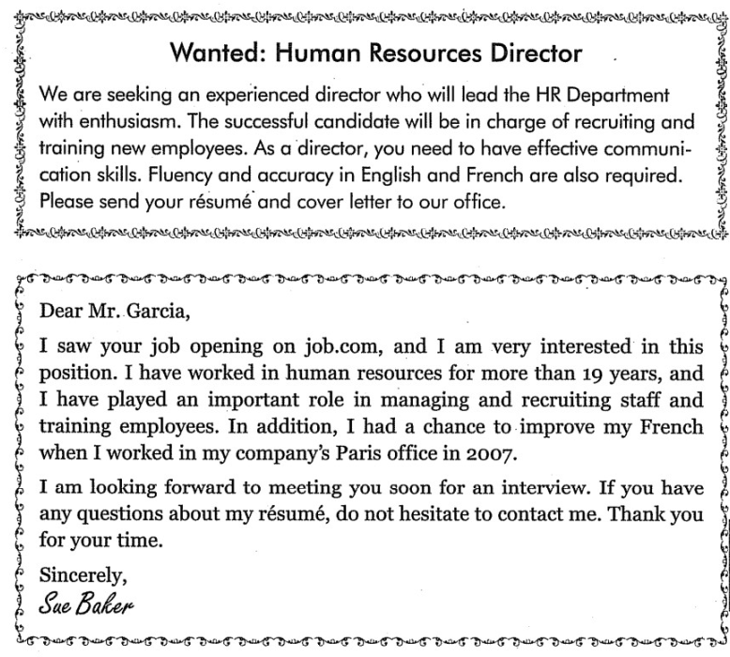

21. What is NOT a stated requirement?

(A) Fluency in English and French

(B) Experience in human resources

(C) Good communication skills

(D) Excellence in managing a company

22. Why did Sue write the letter to Garcia?

(A) To ask some questions

(B) To cancel the job interview

(C) To apply for the job

(D) To reply to Garcia's letter

Reading - test 1 - TOEIC ETS 1200

Questions 23-25 refer to the following email.

From: Summers, Jennifer

To: Editing staff

CC: Management, supervisory staff

Subject: Unclaimed print copies

Hi all,

A box has been placed next to the printer for unclaimed print copies to avoid a mess of papers being left on the printer table at the end of the day.

I'd like to remind you to pick up all your copies as soon as possible after you print them. This has been the clear guideline for several months now, so please try to follow through with it. It is particularly important that confidential documents be picked up immediately after printing.

Thank you for your cooperation.

Jennifer

23. What problem does the e-mail address?

(A) The printer is not working properly.

(B) The area around the printer has been left untidy.

(C) Employees were not told of a change in guidelines.

(D) Office regulations are unclear.

24. What does Jennifer ask the employees to do?

(A) Keep confidential papers off their desks

(B) Check with a supervisor for instructions

(C) Collect documents from the printer table

(D) Cover the printer at the end of each day

25. Why does Jennifer thank the employees?

(A) To indicate that the managers are pleased

(B) To acknowledge their efforts over the last few months

(C)To emphasize the importance of their work

(D) To encourage them to do what she has asked

Questions 26-27 refer to the following memo.

Goodman Theater Company

CONFIDENTIAL

Date: July 11

To: Charlie Ullman

From: Gordon Furr

Re: Budget Approval Concerns

Thank you for attending Wednesday's meeting. I'm glad that after exploring several possibilities we were able to come to an agreement on ways to reduce spending in next year’s equipment budget. Because of this $2,000 reduction, I have no doubt that our chairperson Renée Walker will approve the new budget at Friday's meeting. See you in the conference room on Friday.

26. What problem is mentioned in the memo?

A. A meeting had to be rescheduled

B. A conference room is unavailable.

C. Spending had to be reduced.

D. Some money was lost.

27. What is Renée Walker expected to do on Friday?

A. Approve a budget

B. Order equipment

C. Attend a theater performance

D. Plan a theater schedule

Questions 28-29 refer to the following e-mail.

From: Anya Patel <apatel @ southeastind .com〉

To: Tom Ramon [tramon@southeastind.com](mailto:tramon@southeastind.com)

Subject: Ceremony for Josephine Coletti

Date: June 10

Hi Tom,

I suppose you’ve heard that we are planning a ceremony to honor Josephine Coletti’s 25 years at Southeast Industries. I’d like to know if you could say a few words about her contributions to your department as well as present her with the award (a plaque and gift certificate). As sales director and Josephine’s immediate supervisor for the past 18 years, you probably know her better than anyone else here. You will receive the official invitation with more details by the end of the week.

Please let Susan Chen, my executive assistant (extension 4092), know if you will be able to attend and if you’d be willing to give a short speech.

Thanks.

Anya Patel, Vice President

28. Who is Josephine Coletti?

(A) Tom Ramon's immediate supervisor

(B) A sales department employee

(C) A worker who recently retired

(D) A vice president at Southeast Industries

29. What is Mr. Ramon asked to do?

(A) Attend a luncheon

(B) Reserve a meeting room

(C) Order food for a party

(D) Make a presentation

Questions 30-31 refer to the following advertisement.

Are you a lively conversationalist and an inspiring cook?

How would you like to be the host of The Half-Hour Chef, a new television program scheduled to start broadcasting in February?

Try your luck at VAL-TV's Studio 6 on December 5 by demonstrating your cooking in action. We have all the appliances you’ll need. Just bring your own ingredients. Our program directors are not interested in your professional experience or personal portfolio. What they want to see is your on-the-air potential as a live performer. So drop by our studio at 9:00 A.M. and show us what you can do!

30. What position is being advertised?

(A) Restaurant chef

(B) Television show host

(C) Program director

(D) Cookbook editor

31. What are interested candidates asked to do?

(A) Provide their food ingredients

(B) Invent a new food recipe

(C) Watch a live television program

(D) Submit photographs of their work

Questions 32-34 refer to the following letter.

214 Ryland Avenue Miami, Florida 00432 May 30

Dear Ms. Kovin

Our records show that the June issue of Today's Trends will be your last and that you have not yet renewed your subscription. To encourage you to renew, we would like to offer you Today's Trends at a reduced price. You are currently paying $3.00 per issue. We will offer you the magazine for six months at only $2.25 per monthly issue. That means that you will save a total of $4.50 from July to December if you renew your subscription.

Please contact our business office at 888-555-3214 Monday through Friday from 9 A M. to 5 P.M. or on Saturday from 10 A.M. to 3 P.M. The business office is closed on Sundays. We look forward to continuing to serve you in the future.

Sincerely,

Marsha Clemmins

Director of Sales

32. What is the purpose of the letter?

(A) To explain an increase in fees

(B) To confirm that a payment was received

(C) To request that a bill be paid

(D) To offer a discount to a customer

33. When will Ms. Kovin’s current subscription end?

(A) In May

(B) In June

(C) In July

(D) In December

34. What is Ms. Kovin currently paying for her subscription per month?

(A) $2.25

(B) $3.00

(C) $4.50

(D) $6.00

Reading - Test 1 - TOEIC ETS 1000

Questions 35-36 below refer to the following postcard.

May 4

Dr. Charles Somerville Mr. Steven Hines

1785 Taylor street 15 Greenwood way

Allentown, PA 18102 Bethlehem, PA 18018

This is a friendly reminder that your next dental cleaning is scheduled for Friday, May 11, at 8:30 A.M. If you are unable to keep your appointment, please call us by 3:00 P.M. on Wednesday, May 9, during regular office hours. We can be reached from 8:00 A.M. to 5:00 P.M., Monday through Saturday, at 555-0119.

Please note, we will be closed on Monday, May 28 for the holiday.

35. When does Mr. Hines have an appointment?

1. On May 11
2. On May 4
3. On May 9
4. On May 28

36. According to the postcard, why would Mr. Hines call the dental office?

1. To make a payment
2. To cancel an appointment
3. To request information
4. To confirm an appointment

Questions 37-38 below refer to the following information.

Greengage Conference Center

Located just 40 minutes from the Charlotte Airport, Greengage Conference Center is the perfect place to hold your next corporate event. Situated among beautiful rolling hills and woodlands, our center provides a private, peaceful area. We offer conference facilities and meeting rooms that are equipped with everything you need for multimedia presentations. We also offer a fully equipped business center with a complete suite of office productivity software, complimentary wireless Internet access, two restaurants, and a banquet hall.

Call 704-555-0175 to speak to our professional event associates, who are prepared to help you with every phase of event planning.

37. What is indicated about Greengage Conference Center?

1. It is used mainly by local companies.
2. It has recently been renovated.
3. It offers shuttle service to the airport
4. It is located in a scenic setting.

38. What is NOT mentioned as being available at Greengage Conference Center?

1. Dining facilities
2. On-site hotel rooms
3. Free Internet access
4. Presentation software

Questions 39-41 below refer to the following guest pass.

Present this pass to receive one complimentary visit to

Blue River Fitness Center

• Valid for first-time visitors only.

• Guests must be at least 18 years of age or accompanied by an adult.

• Guests must attend an information session with a staff member to receive a tour of the facility and learn about membership options.

• Valid during limited hours only:

Tuesday to Thursday 10:00 A.M. - 5:00 P.M., Saturday 10:00 A.M. - 3:00 P.M.

Blue River has long been Detroit’s premier fitness center, helping members of all ages and interests to improve their health. Whether you are a novice looking to begin a fitness routine or a fitness expert seeking new challenges. Blue River will help you attain your goals.

39. What must a visitor do in order to use the guest pass?

1. Present identification
2. Complete a survey
3. Meet with a representative
4. Take a fitness test

40. When can the pass be used?

1. On Friday
2. On Monday
3. On Wednesday
4. On Sunday

41. The word "helping" in line 8 is closest in meaning to

1. doing
2. stopping
3. supporting
4. preventing

Questions 42-43 refer to the following notice.

Attention Waylon Concert Hall Guests

• Ticket holders arriving late will not be admitted to the auditorium until a suitable break during the performance and must be shown to their seats by an usher.

• Mobile telephones must be turned off during all performances.

• Cameras and video or audio recorders of any kind are prohibited unless specifically authorized by the promoter. Those found during the performance will be held at the box office until the end of the show.

• Standing in the aisles during performances is forbidden by the fire regulations.

• Smoking is prohibited throughout the building.

• Food or beverages may not be brought into the auditorium at any time.

Please be courteous to those around you while you enjoy the show.

42. What does the notice mainly discuss?

1. Rules for concertgoers
2. Safety procedures
3. Performance schedules
4. Equipment used by concert-hall staff

43. According to the notice, what might a promoter do?

1. Collect mobile phones
2. Support guests who arrive late to their seats
3. Approve the use of audio devices
4. Distribute concert programs

Questions 44-45 refer to the following article.

Johannesburg (7 July) — Jaquin Publishers announced on Friday that Aurelia Martino’s new book, *Stars in the Sky*, will be released on 8 September. This is Ms. Martino’s second book, and early reviews say that readers are in for a treat. Ms. Martino, a famous actress from Johannesburg, decided to give up acting and begin writing books when she had her first child, Matilda, two years ago. She is perhaps best known for her ten-year role as the mother on the popular South African television series *Living with the Monroes.*

44. What is the purpose of the article?

1. To offer an opinion about a book
2. To announce a book release date
3. To profile a famous actress
4. To review a new television series

45. What is suggested about Ms. Martino?

1. She changed careers.
2. She has been an author for over ten years.
3. She recently moved to South Africa
4. She has two children

Questions 46-47 refer to the following telephone message.

Telephone Message

Caller: Dominic Ames

Caller Number: 22 8145 3190

For: Tina Jenkins

Date: Tuesday, June 2

Time: 11:15 A.M.

Details: Dominic in accounting needs to know the exact amount that your department spent on office supplies last month. He is putting together a report for his meeting tomorrow with his department head, Alan Stewart, but is missing figures for sales department spending.

Taken by: Ruth Gordon.

46. Why did Mr. Ames call Ms. Jenkins?

1. To order office supplies
2. To request information about expenses
3. To get approval to work on a project
4. To schedule a board meeting

47. Who is most likely a manager in the sales department?

1. Alan Stewart
2. Tina Jenkins
3. Dominic Ames
4. Ruth Gordon

Questions 48-50 refer to the following e-mail.

From: Tom Gough <tomgough@versatileware,com>

To: Marc Hammond <marchammond@ versatileware.com>

Date: Thursday, June 13,4:12P.M.

Subject: Ride tomorrow?

Hi Marc,

I’m writing to ask a favor of you. My car broke down on my way home today, and I had to take it to the mechanic. Could you give me a ride to and from work tomorrow? I’m hoping it won’t be too much of an inconvenience since we live on the same street and work in the same building. The mechanic says he’ll have the car running again by Saturday, so I shouldn't need a ride on Monday.

Thanks,

Tom

48. What is the purpose of the message?

1. To recommend an auto repair shop
2. To request time off from work
3. To arrange transportation
4. To advertise a car for sale

49. Who most likely is Mr. Hammond?

1. Mr. Gough’s customer
2. Mr. Gough’s coworker
3. Mr. Gough’s landlord
4. Mr. Gough’s auto mechanic

50. The word "favor" line 1, is closest in meaning to

1. help
2. account
3. love
4. work

Questions 51-52 below refer to the following notice.

RETIREMENTS

PATRICIA JOHNSON of the publications office is retiring from DANCO after 25 years of service. Come and join US in wishing her a happy retirement at a gathering in her honor on June 29 in room J-410 at 5 P.M. A $6 donation covers the cost of your refreshments and a gift. Please bring your donation to Anna Hortensen in room P-220 by June 20. For more information, call Anna at extension 7013.

51. Where will the gathering be held?

1. In the publications office
2. At Anna Hortensen’s home
3. In room J-410
4. In room P-220

52. What should people who wish to attend the gathering do?

1. Give a contribution to Anna Hortensen
2. Telephone Patricia Johnson
3. Prepare some food for everyone
4. E-mail the publications office

Questions 53-55 below refer to the following advertisement.

Would you like to be more productive? Do you find that you sometimes have a lot to do but get nothing done? Do you procrastinate? Would you like to be more organized? Are you tired of being rushed or under pressure?

Enroll in the Time Management workshop and learn how to plan and schedule work, how to set goals and overcome procrastination, and how to set priorities and follow through on them.

The workshop will be held on October 26 and run for three hours. Two identical sessions will be offered — one from 1 P.M. to 4 P. M. and the other from 5:30 P.M. to 8:30 P.M. Please choose thee one that works best with your schedule. Contact Marcy Halford at extension 425 for more information.

53. What is being advertised?

1. A club
2. A workshop
3. A computer program
4. A job

54. For whom is the advertisement probably intended?

1. People who work quickly
2. Recently retired people
3. People with planning experience
4. Unorganized people

55. How long is each session?

1. Five hours
2. Three hours
3. One hour
4. Two hours

Questions 56-58 below refer to the following letter.

World Banking Corporation

Plaza Del Sol 23

Madrid, Spain

7 March

Mario Gonzalez

Calle de los Reyes 7158-160

Madrid, Spain

Dear Mr. Gonzalez,

Thank you for sending US your application for the junior accounting position. Your résumé will initially be evaluated by two senior staff members. If you are selected for an interview, Estela Morales, our personnel officer, will contact you by telephone. At that time we will need to have the names and addresses of three references.

As you requested, enclosed is a copy of our most recent annual report. Thank you for your interest in World Banking Corporation.

Yours sincerely,

Ronald Martinez

Office Manager

Enc.

56. For what position did Mr. Gonzalez apply?

1. Records officer
2. Office manager
3. Junior accountant
4. Personnel officer

57. Who will contact Mr. Gonzalez for an interview?

1. A senior accountant
2. A junior staff member
3. Estela Morales
4. Ronald Martinez

58. What is being sent with the letter?

1. A bank statement
2. An annual report
3. An application form
4. A staff directory

Questions 59-61 refer to the following announcement.

Attention Clients of Doyle, Inc.

While waiting for its permanent headquarters to be completed, architectural and engineering firm Doyle, Inc., will be moving its offices just down the street as of September 1. The move from 1102 Main street to 813 Main street will be temporary (until the completion of the firm’s new permanent headquarters at the Odessa Business Center). We would like to assure you that business will continue as usual and none of our current projects will be delayed as a result of this move. Please note, however, that our involvement with the university’s architectural intern program will be postponed this summer and will not resume until next year.

59. What is being announced?

1. The opening of a university
2. The relocation of a company
3. The closing of a firm
4. The merger of two organizations

60. Where are the offices of Doyle, Inc., currently located?

1. At the local university
2. At 1102 Main Street
3. At 813 Main Street
4. At the Odessa Business Center

61. What will be delayed?

1. A company’s annual meeting
2. The completion of architectural plans
3. The construction of a business center
4. A company’s participation in a program

Questions 62-63 refer to the following invitation.

In recognition of your generosity as a museum member, you are invited to attend a special reception celebrating the opening of the A. C. Hamilton Wing for European Art at the Canterville Museum.

To commemorate the occasion, a speech will be given by Dr. Florian Pirotta of Denmont University:

''The Landscape Paintings of Carlo Giulini."

Friday, February 25, 6:30 P.M.

Light refreshments will be served.

This event is made possible in part by a contribution from the Elisabeth Kristeller Memorial Foundation.

62. Who would mostly likely receive the invitation?

1. Art students at local universities
2. Members of the Canterville Museum
3. Owners of prominent art galleries
4. Artists who were trained in Europe

63. What is the main subject of the talk?

1. Contemporary photography
2. Artwork by Cario Giulini
3. An ongoing construction project
4. The life of Elisabeth Kristeller

Reading Test 5 - TOEIC ETS 1000 -(5)

Questions 64-65 refer to the following announcement.

Wong’s picture frames

The staff at Wong's Picture Frames would like you to join US on our opening day. When you visit US this Friday, December 1, you will be eligible for a 10% discount on any item! Just mention coupon code WPF1OD at the time of purchase. We are located at the corner of Willow and Randall Avenues, and our hours of operation are 9:00 A.M.-6:00 P.M., Tuesday through Sunday.

We are confident that you will love our selection of frames. Our frame specialists will be happy to answer any questions you may have, and they will help you to choose the frame that is right for you.

For more information, visit US online at www.wongspictureframes.com, or call US at (814) 555-0224.

64. On what day is Wong’s Picture Frames closed?

1. Sunday
2. Friday
3. Tuesday
4. Monday

65. According to the announcement, how can customers receive a discount?

1. By joining a mailing list
2. By providing coupon details
3. By referring other customers
4. By visiting a Web site

Questions 66-68 refer to the following memo.

MEMO

Date: July 25

To: Canary Wharf Productions Employees

From: Althea Lee, Human Resources

Re: Building escalators

Escalators in the first-floor lobby will be closed beginning on Monday; August 1, so that a new motor and handrail can be installed. Barring unexpected delays, they will be back in service by the following Monday.

To access the second floor of the building, take the stairway located next to the service elevator on the east side of the building. Do NOT use the freight elevator itself, as it is reserved for equipment, supplies, and other heavy items, and cannot accommodate additional traffic from employees. If you need an elevator, use the passenger elevators near the Baywater Street entrance on the north side of the building.

66. Why are the escalators being closed?

1. A special event is taking place in the lobby
2. Maintenance is being performed on them
3. They have been replaced by a new elevator.
4. They need to be expanded to accommodate increased traffic.

67. For how long are the escalators expected to be closed?

1. One week
2. A few hours
3. Two days
4. One day

Questions 68-70 refer to the following sign.

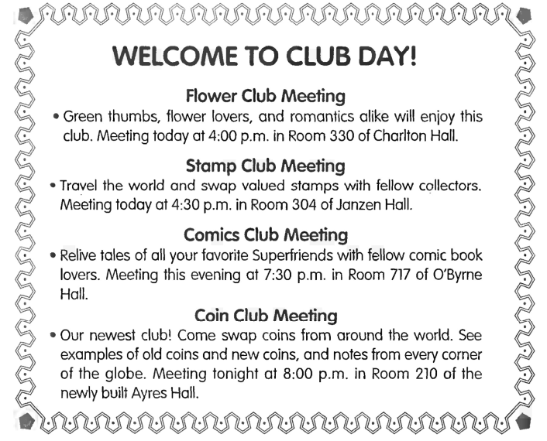

68. What time is the Flower Club Meeting?

(A) 3:30 p.m.

(B) 3:04 a.m.

(C) 4:00 p.m.

(D) 4:30 p.m.

69. Where is the Stamp Club Meeting?

(A) Room 330

(B) Room 304

(C) Room 400

(D) Room 430

70. Which building was built most recently in Coin Club Meeting?

(A) Charlton Hall

(B) Janzen Hall

(C) O'Byrne Hall

(D) Ayres Hall

# **Task 4: Text completion**

lấy 18 câu đầu trong test bank và 18 câu sau trong giáo trình.

Reading - test 2 - TOEIC ETS 1200

Directions: Read the texts that follow. A word or phrase is missing in some of the sentences. Four answer choices are given below each of the sentences. Select the best answer to complete the text. Then mark the letter (A), (B), (C) or (D) on your answer sheet

Questions 1-3 refer to the following letter.

Dear Mr. Geremi,

We are very pleased that you have accepted a summer position with us as a computer

(1) ________. The work will begin on June 28 and end on August 15. The pay will be $850 per week.

1.

(A) technician

(B) technique

(C) technicians

(D) techniques

On your first day of work, please (2)_______ to bring a valid form of identification and the

2.

(A) remembering

(B) to remember

(C) remember

(D) are remembered

completed tax forms we sent you earlier this month. After you have submitted these forms and your identification has been copied for our records, there will be a reception in the Wooley Building to welcome all interns. Following the reception, the specific details of your job responsibilities will be (3)________ .

3.

(A) provide

(B) provided

(C) providing

(D) provides

We look forward to seeing you on June 28.

Warm regards,

Bill Bella

Coordinator, Summer Work Program Chadwick

Chemical Corporation

Questions 4-6 refer to the following article.

Wholesale food stores are becoming increasingly popular among thrifty shoppers. Unlike

(4) ________ supermarkets, which have always relied on marketing departments to advertise

4.

(A) tradition

(B) traditional

(C) traditionally

(D) traditions

products, wholesale stores sell directly to the consumer. This distribution method can result in considerably lower prices.

Wholesale stores typically offer little personalized assistance and in the past have served only specialty shops and restaurants. However, due to a concerted effort in recent years by these stores to attract (5)________ shoppers, this is slowly changing. (6)________ , many consumers are now quite happy to shop at wholesale stores as well as supermarkets.

5.

(A) individual

(B) individualize

(C) individually

(D) individuals

6.

(A) Because

(B) In fact

(C) On the other hand

(D) Despite

Questions 7-9 refer to the following article.

Higher Gasoline Prices Are Everyone's Business

The retail price of fuel continues its steady rise for the tenth week in a row, and experts say there is no immediate end in sight.

Preston Okura, director of Henson Oil & Gas, Inc., made a similar (7) ____________

7.

(A) observe

(B) observations

(C) observation

(D) observes

Attributing the sharp increase in fuel prices to higher crude oil prices, he expects prices to continue (8)______ for another month.

8.

(A) rise

(B) rising

(C) be rising

(D) have risen

While businesses like trucking and shipping companies are feeling the direct impact of these high prices, the (9)________ on the general public may be less evident.

9.

(A) effect

(B) effecting

(C) effected

(D) effective

“Every item that ends up in the store has a freight cost built into it,” said Okura. "These transport companies have no choice but to charge higher fees and to pass on the cost to their customers."

Reading - Test 2 - TOEIC ETS 1000

Questions 10-12 refer to the following advertisement.

Kashio's Grand Opening Celebration

Kashio's, a new seafood restaurant in Haverton, invites you to our grand opening on Saturday, May 1. Enjoy complimentary food samples, live music, and discounts on meals at the party! (10)______ the event, all dinner entrees and desserts will be 25 percent off. Our wait staff will offer

10.

1. Of
2. Between
3. Beside
4. During

a selection of tasty appetizers, free of charge, throughout the evening. In addition, (11)_______ will be provided by local favorite Melody McRae.

11.

1. techniques
2. service
3. entertainment
4. reservations

We are located at the intersection of Clinton Boulevard and Park Avenue, (12)____ adjacent to Community Theater.

12.

1. direct
2. directed
3. directive
4. directly

Stop in before or after your visit to the theater; we will be open seven days a week, from 4:00 P.M. to 11:00 P.M., starting May 1.

Questions 13-15 refer to the following letter.

5 November

Sneha Ramachandran

A-301, Pali Hili Residency

Kantwadi Road

Mumbai 400050

India

Dear Ms. Ramachandran,

I received your letter inquiring about the status of your order of John Wilkinson’s Guide to Gourmet Cooking. Our inventory report indicates that there is one copy of the book in stock. (13) _______, the book cannot be located in our store or at our warehouse. The book is also out of

13.

1. Later
2. Unluckily
3. Often
4. Similarly

print and can no longer be ordered from the publisher.

Nonetheless, I have been able to locate a (14) ________ of the book in our used book division and can offer it to you at half the price. I will waive any shipping charges. The copy shows only (15)_______ signs

14.

1. copies
2. copys
3. copying
4. copy

15.

1. minimize
2. minimal
3. minimalism
4. minimalist

of wear, and there is an inscription on the title page. If you would like this copy, please let me know, and I will mail it to you immediately.

Sincerely,

B.v. Bhatti

Owner, Bhatti Bookstore

Questions 16-18 refer to the following information.

Mbedzi and Partners charges clients an hourly rate based on the type of service needed and level of expertise of the assigned lawyer. Base charges (16)_______ R 3,000 per hour for senior

16.

1. be
2. being
3. is
4. are

consultants; R 1,800 for associates; and R 900 for candidate attorneys. We do, (17)_____ , adjust pricing for corporate clients who use our firm exclusively for all their legal services.

17.

1. if
2. or
3. however
4. unless

We can also provide a calculation of expected costs for an entire project in order to assist clients in accurately (18) ______ expenses. Contact our billing department for complete details on our fee structure and policies: billing@mbedziandpartners.co.za.

18.

1. predict
2. predicting
3. predicts
4. prediction

Questions 19-21 refer to the following letter.

Mr. David Hornsby

190 Broadway

Vancouver, BC

Dear Mr. Hornsby,

I am writing this letter (19) ________ that you will (20) ________ working for Big Office Supplies

19. (A) confirm (B) to confirm

(C) confirming (D) for confirming

on April 12. Your job duties will be explained during the training session.

20.

A. starting

B. having started

C. start

D. started

As we discussed before, you will be able (21) _______ twenty days of vacation and

21. (A) have (B) having

(C) to having (D) to have

three sick days. If you have any questions, please let us know.

Question 22-24 refer to the following letter.

Dear Mr. Myer,

According to our records, your membership with California Fitness will (22)_______ in a few weeks.

22.

A. expired

B. expiring

C. expire

D. to expire

We would like (23) ________ you with a special offer. With your renewal of your membership,

23. (A) to provide (B) provide

(C) providing (D) provided

you can continue (24) _________ our facilities and services at a discounted price.

24. (A) use (B) used

(C) using (D) uses

Sincerely,

Jane Miller

Questions 25-27 refer to the following notice.

Accounting Employees,

We will have performance reviews over the next week, (25) ________ I would like to tell

25. (A) so (B) but (C) since (D) because

you the review process.

First of all, we will (26) _________ each of you in person.

26.

A. interview

B. interviewing

C. to interview

D. interviewed

Second, you will have to fill out the evaluation form for yourself (27) _______ return it to the Personnel Department.

27. (A) so that (B) but (C) and (D) now that

Lastly, we will write a report that summarizes your performance.

We all hope that this is a great chance to improve your job performance.

Questions 28-30 refer to the following memo.

This memo is to inform you that our branch office will be renovated. The renovations will begin (28) _________ October 21 and are expected to be finished by December.

28. (A) as (B) on

(C) in (D) at

Therefore, all employees should (29) _________ the small building on Broadway from Monday.

29.

A. use

B. using

C. to used

D. used

If you have any questions (30) ________ the location of the building, contact Ms. Endley in the Personnel Department.

30. (A) concerning (B) concerns

(C) concern (D) concerned

Questions 31 through 33 refer to the following email.

To: sspt09@ccu.co

From: tatkins@netto.com

Subject: Contract

Date: June 3rd

Dear Mr. Conrad,

I am writing to you (31) ______ the contract we made last week.

31. (A) about (B) of (C) along (D) in

In the contract, you promised (32) _______ use any workers without consulting me first.

32. (A) to not (B) to don’t (C) to didn’t (D) not to

However, this morning I found two new workers on the building site. I (33) _______ met them before, and I was not told about them. I do not want a repeat of this. Please honor our contract. I am very disappointed by this.

Tom Atkins

33. (A) am not (B) will not (C) had not (D) be not

Questions 34 through 36 refer to the following advertisement.

Tired (34) ______ your image? Fed up with your hair style? Don’t want to wear the same

34. (A) by (B) of (C) from (D) to

old clothes again and again? Then you need 'Image Over? We advise clients on how to make the most of their appearance. Don’t want to spend a lot of money on clothes and make-up? No problem. You don’t have to be rich to look good. We can show you cheap and easy ways to improve your appearance and create a new look.

Call 435-945 to make an appointment. One of (35) ______ specialists will visit your home

35. (A) us (B) ours (C) our (D) mine

and check your clothes and make-up. Then, the specialist will take you on a fun shopping trip to (36)_______ you find things to improve your look. Call now and start looking great!

36. (A) help (B) show (C) make (D) do

# **Task 5: listening**

*Listen and choose the statement that best describes the picture ( chọn đáp án đúng nhất để diễn tả tranh) (50 câu)*

 test 1 - ETS 1000

Link drive: https://drive.google.com/file/d/1Ho0es4faHgZD6lZy4PwLvl_CdKeaaNB6/view?usp~share_link

::CH1O1::

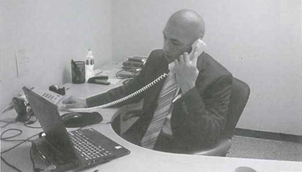

{

~ A

~ B

~ C

~ D

}

::CH1O2::

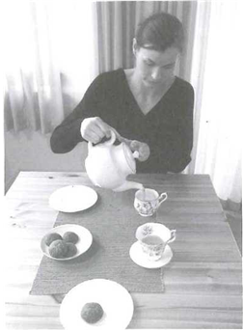

{

~ A

~ B

~ C

~ D

}

::CH1O3::

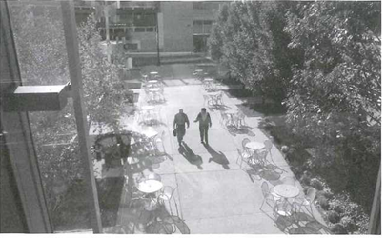

{

~ A

~ B

~ C

~ D

}

::CH1O4::

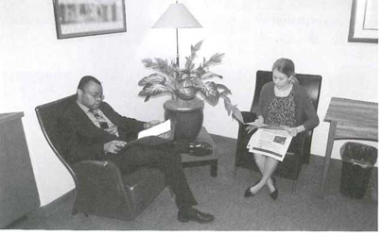

{

~ A

~ B

~ C

~ D

}

::CH1O5::

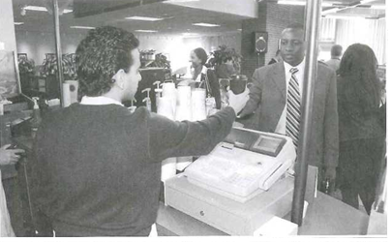

{

~ A

~ B

~ C

~ D

}

::CH1O6::

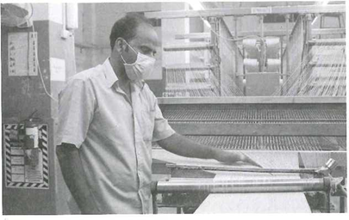

{

~ A

~ B

~ C

~ D

}

::CH1O7::

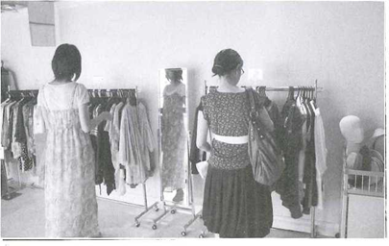

{

~ A

~ B

~ C

~ D

}

::CH1O8::

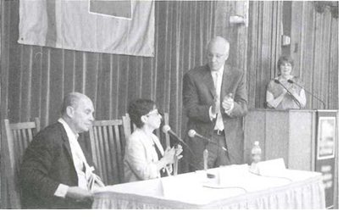

{

~ A

~ B

~ C

~ D

}

::CH1O9::

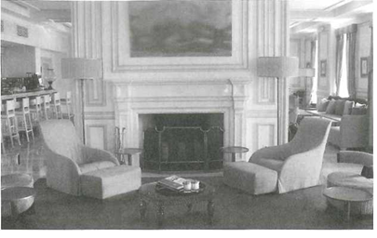

{

~ A

~ B

~ C

~ D

}

::CH110::

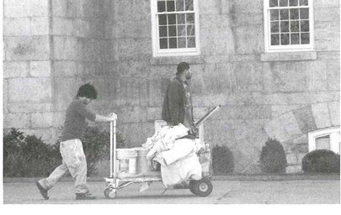

{

~ A

~ B

~ C

~ D

}

Practice with TOEIC actual questions (Track 1-3-08 - ETS 2016 – test 3) ( sách giáo trình )

Link audio : [https://drive.google.com/file/d/152OcfCAcL7wcH5ngrWC1guKb96eeEVSU/view?usp~share_link](https://drive.google.com/file/d/152OcfCAcL7wcH5ngrWC1guKb96eeEVSU/view?usp=share_link)

::CH111::

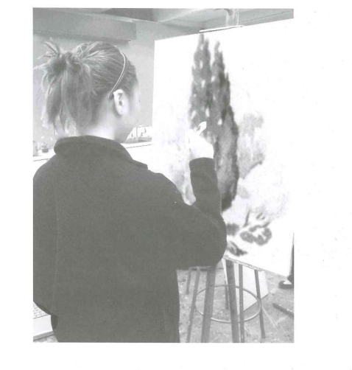

{

~ A

~ B

~ C

~ D}

::CH112::

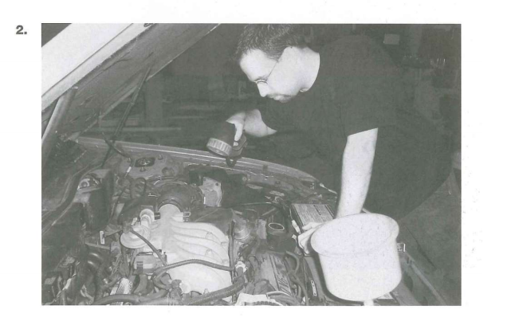

{

~ A

~ B

~ C

~ D

}

::CH113::

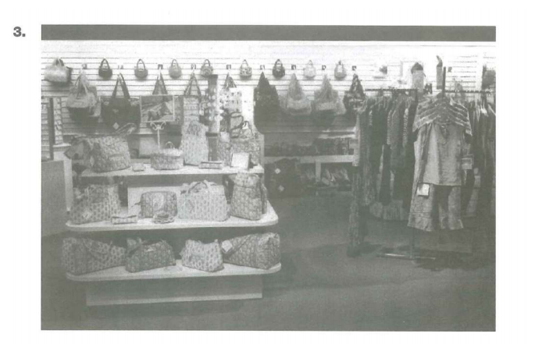

{

~ A

~ B

~ C

~ D}

::CH114::

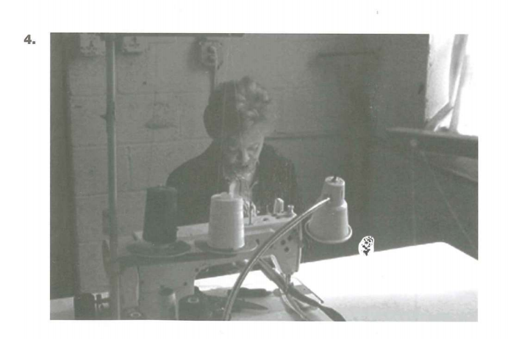

{

~ A

~ B

~ C

~ D

}

::CH115::

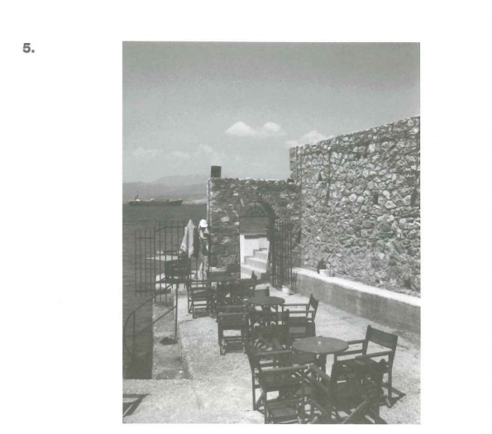

{

~ A

~ B

~ C

~ D

}

::CH116::

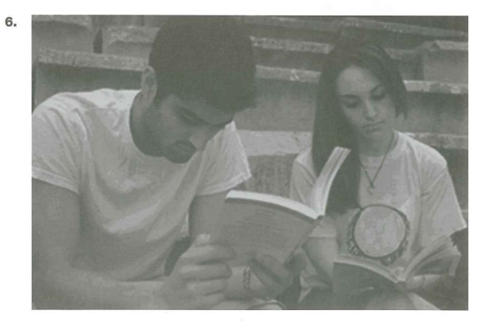

{

~ A

~ B

~ C

~ D

}

::CH117::

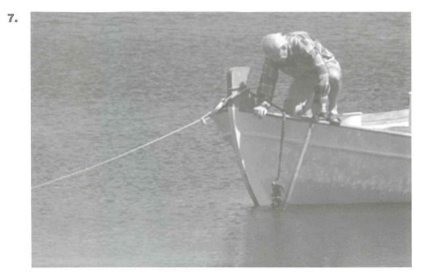

{

~ A

~ B

~ C

~ D

}

::CH118::

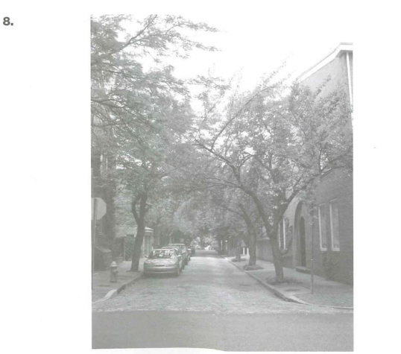

{

~ A

~ B

~ C

~ D

}

::CH119::

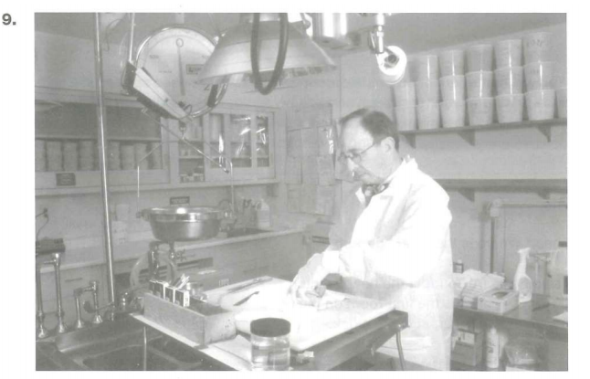

{

~ A

~ B

~ C

~ D

}

::CH120::

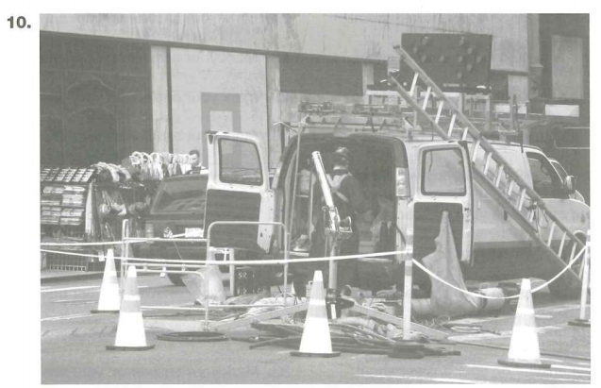

{

~ A

~ B

~ C

~ D

}

( Toeic test bank )

test 1 - ETS 1200

[https://drive.google.com/file/d/1Hhqt-rfopPuzBpS9Ha8ORdksf754GYkb/view?usp~share_link](https://drive.google.com/file/d/1Hhqt-rfopPuzBpS9Ha8ORdksf754GYkb/view?usp=share_link)

::CH121::

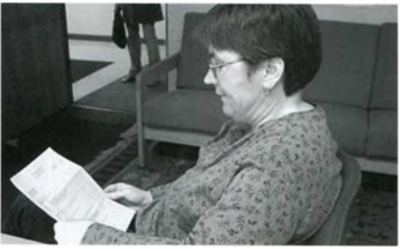

{

~ A

~ B

~ C

~ D

}

::CH122::

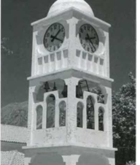

{

~ A

~ B

~ C

~ D

}

::CH123::

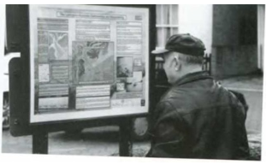

{

~ A

~ B

~ C

~ D

}

::CH124::

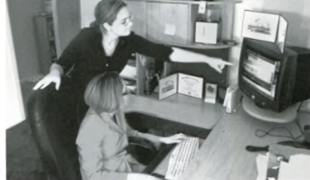

{

~ A

~ B

~ C

~ D

}

::CH125::

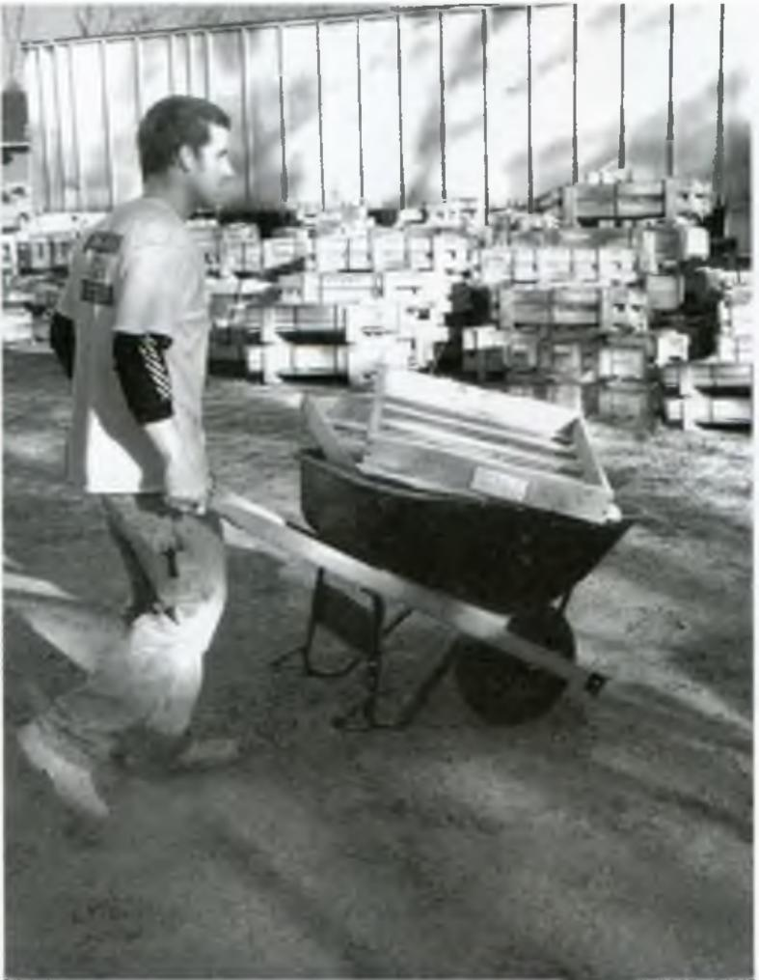

{

~ A

~ B

~ C

~ D

}

::CH126::

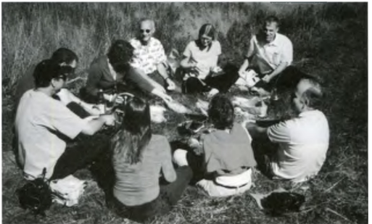

{

~ A

~ B

~ C

~ D

}

::CH127:

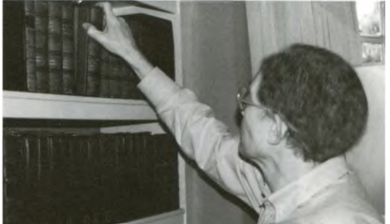

{

~ A

~ B

~ C

~ D

}

::CH128::

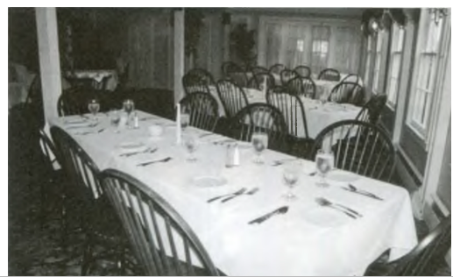

{

~ A

~ B

~ C

~ D

}

::CH129::

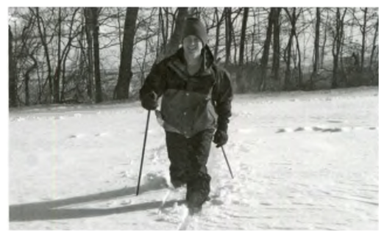

{

~ A

~ B

~ C

~ D

}

::CH130::

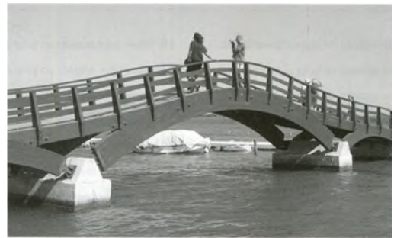

{

~ A

~ B

~ C

~ D

}

test 2 - ETS 1200 [https://drive.google.com/file/d/1QAzy9lyfCU90ypsStRfcgI1ZV5SEbLXG/view?usp~share_link](https://drive.google.com/file/d/1QAzy9lyfCU90ypsStRfcgI1ZV5SEbLXG/view?usp=share_link)

::CH131::

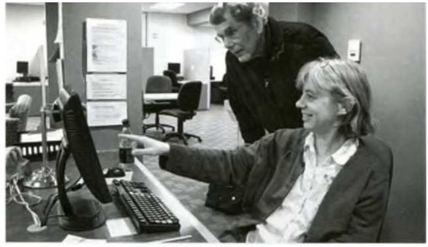

{

~ A

~ B

~ C

~ D

}

::CH132::

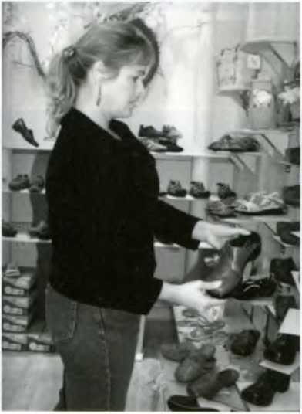

{

~ A

~ B

~ C

~ D

}

::CH133::

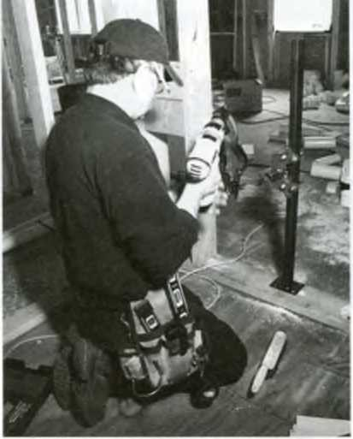

{

~ A

~ B

~ C

~ D

}

::CH134::  
 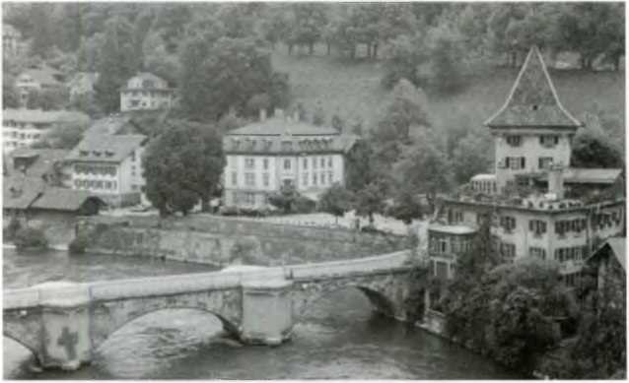 {

~ A

~ B

~ C

~ D

}

::CH135::   
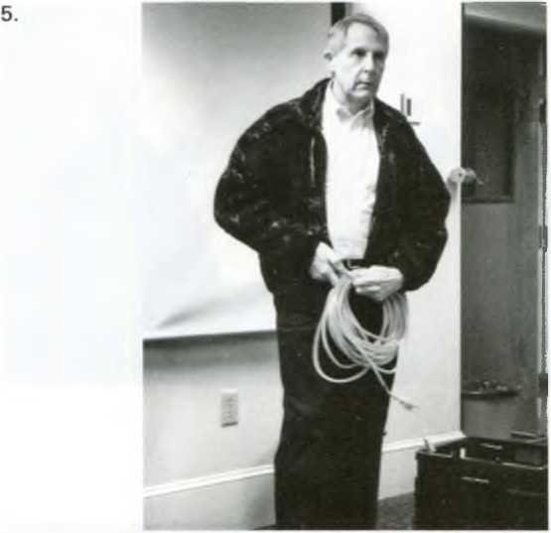

{

~ A

~ B

~ C

~ D

}

::CH136::

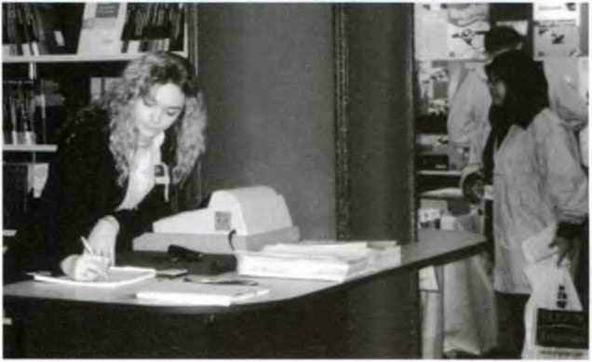

{

~ A

~ B

~ C

~ D

}

::CH137::

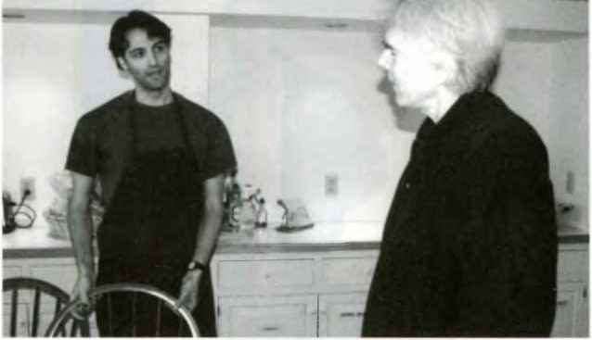

{

~ A

~ B

~ C

~ D

}

::CH138::

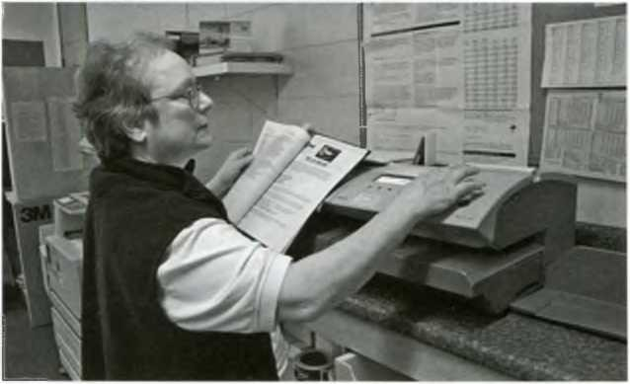

{

~ A

~ B

~ C

~ D}

::CH139::

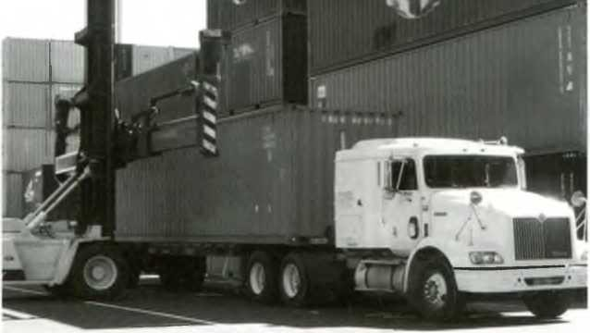

{

~ A

~ B

~ C

~ D

}

::CH140::

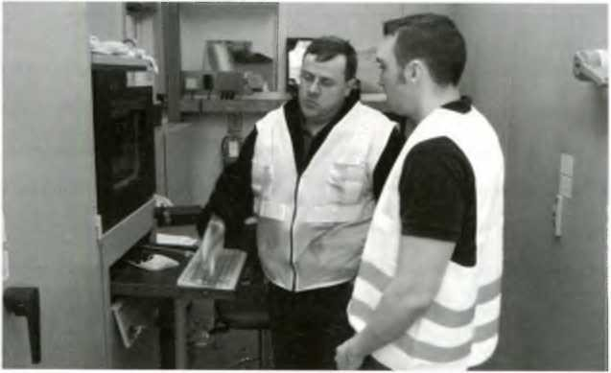

{

~ A

~ B

~ C

~ D

}

Listening - test 3 - ETS 1200

[https://drive.google.com/file/d/1YFjVmZNVrLTNVtZ12um-SK_fZiZumLpB/view?usp~share_link](https://drive.google.com/file/d/1YFjVmZNVrLTNVtZ12um-SK_fZiZumLpB/view?usp=share_link)

::CH141::

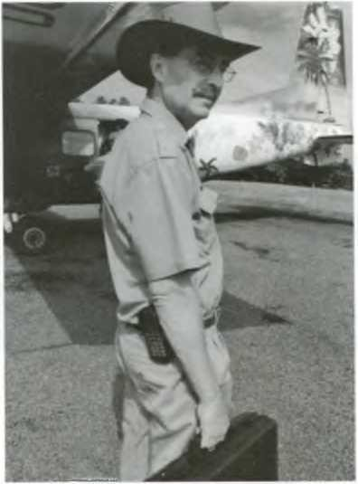

{

~ A

~ B

~ C

~ D

}

::CH142::

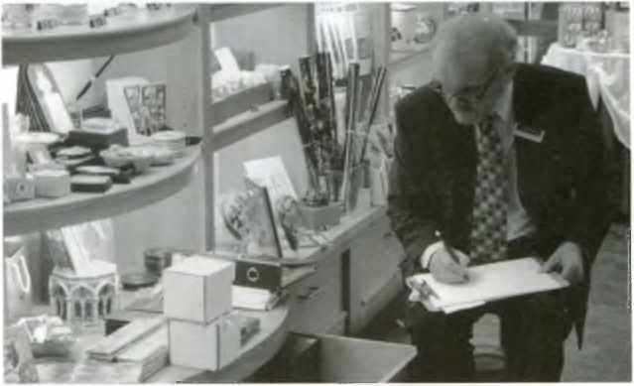

{

~ A

~ B

~ C

~ D

}

::CH143::

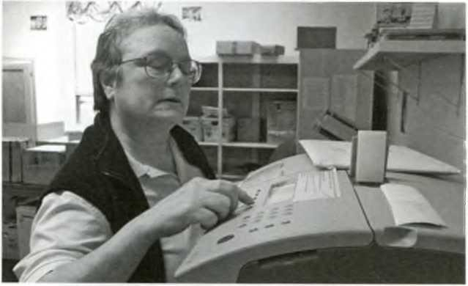

{

~ A

~ B

~ C

~ D

}

::CH144::

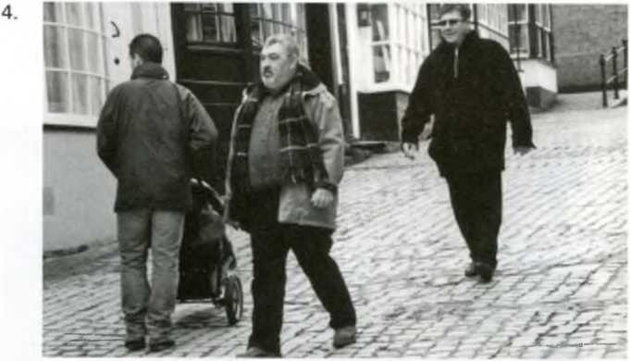

{

~ A

~ B

~ C

~ D

}

::CH145::

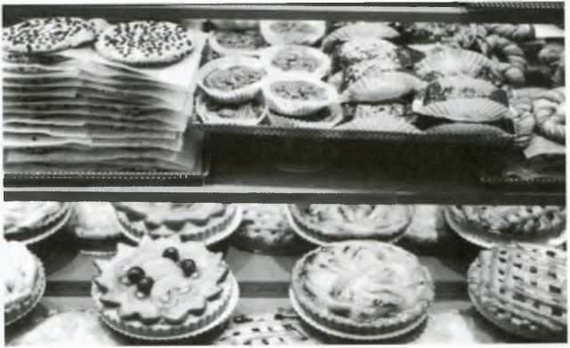

{

~ A

~ B

~ C

~ D

}

::CH146::

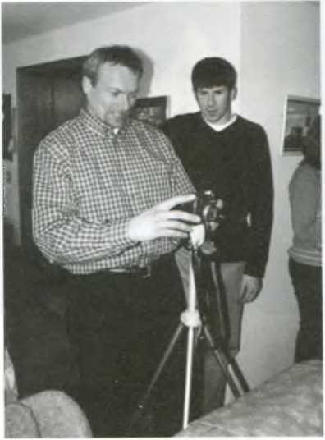

{

~ A

~ B

~ C

~ D

}

::CH147::

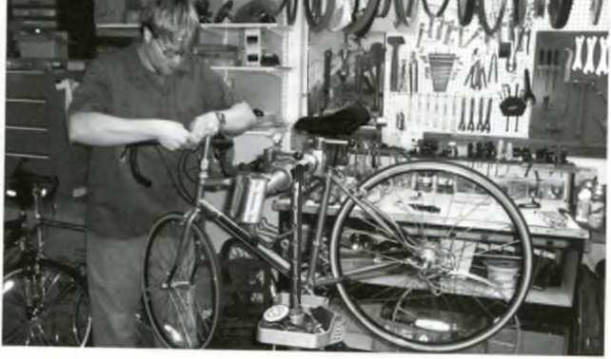

{

~ A

~ B

~ C

~ D

}

::CH148::

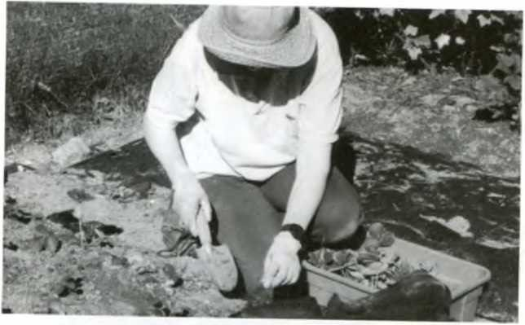

{

~ A

~ B

~ C

~ D

}

::CH149::

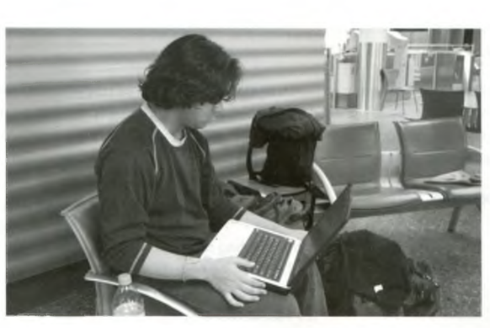

{

~ A

~ B

~ C

~ D

}

::CH150::

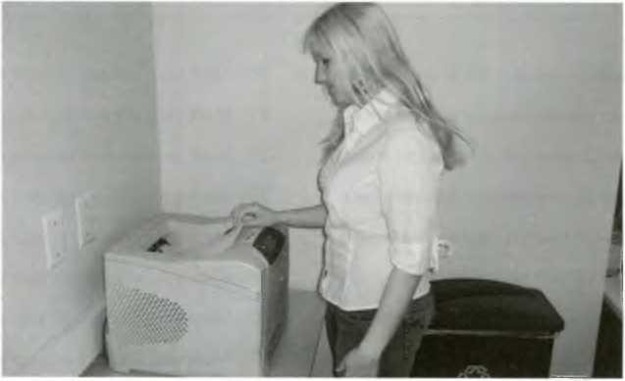

{

~ A

~ B

~ C

~ D

}

# **Task 6: listening**

*Listen to the questions and three responses. Choose the most suitable response (50 câu).*

QUESTION WITH WHO (2-1-12)

*Link file nghe*: <https://drive.google.com/drive/u/2/folders/1Fep_ydhAQvP0gDe4XwjYjNYTldmt-RvR>

1

A

B

C

2

A

B

C

3

A

B

C

4

A

B

C

5

A

B

C

*Link file nghe:* [*https://drive.google.com/drive/u/2/folders/1Fep_ydhAQvP0gDe4XwjYjNYTldmt-RvR*](https://drive.google.com/drive/u/2/folders/1Fep_ydhAQvP0gDe4XwjYjNYTldmt-RvR)

6

A

B

C

7

A

B

C

8

A

B

C

9

A

B

C

10

A

B

C

QUESTION WITH WHERE 2-2-12

*Link file nghe:* [*https://drive.google.com/drive/u/2/folders/1Fep_ydhAQvP0gDe4XwjYjNYTldmt-RvR*](https://drive.google.com/drive/u/2/folders/1Fep_ydhAQvP0gDe4XwjYjNYTldmt-RvR)

1

A

B

C

2

A

B

C

3

A

B

C

4

A

B

C

5

A

B

C

*Link file nghe:* [*https://drive.google.com/drive/u/2/folders/1Fep_ydhAQvP0gDe4XwjYjNYTldmt-RvR*](https://drive.google.com/drive/u/2/folders/1Fep_ydhAQvP0gDe4XwjYjNYTldmt-RvR)

6

A

B

C

7

A

B

C

8

A

B

C

9

A

B

C

10

A

B

C

QUESTION WITH WHEN 2-3-13

*Link file nghe:* [*https://drive.google.com/drive/u/2/folders/1Fep_ydhAQvP0gDe4XwjYjNYTldmt-RvR*](https://drive.google.com/drive/u/2/folders/1Fep_ydhAQvP0gDe4XwjYjNYTldmt-RvR)

1

A

B

C

2

A

B

C

3

A

B

C

4

A

B

C

5

A

B

C

*Link file nghe:* [*https://drive.google.com/drive/u/2/folders/1Fep_ydhAQvP0gDe4XwjYjNYTldmt-RvR*](https://drive.google.com/drive/u/2/folders/1Fep_ydhAQvP0gDe4XwjYjNYTldmt-RvR)

6

A

B

C

7

A

B

C

8

A

B

C

9

A

B

C

10

A

B

C

QUESTION WITH WHY 2-4-12

*Link file nghe:* [*https://drive.google.com/drive/u/2/folders/1Fep_ydhAQvP0gDe4XwjYjNYTldmt-RvR*](https://drive.google.com/drive/u/2/folders/1Fep_ydhAQvP0gDe4XwjYjNYTldmt-RvR)

1

A

B

C

2

A

B

C

3

A

B

C

4

A

B

C

5

A

B

C

*Link file nghe:* [*https://drive.google.com/drive/u/2/folders/1Fep_ydhAQvP0gDe4XwjYjNYTldmt-RvR*](https://drive.google.com/drive/u/2/folders/1Fep_ydhAQvP0gDe4XwjYjNYTldmt-RvR)

6

A

B

C

7

A

B

C

8

A

B

C

9

A

B

C

10

A

B

C

QUESTION WITH WHAT 2-5-13

*Link file nghe:*

<https://drive.google.com/drive/u/2/folders/1Fep_ydhAQvP0gDe4XwjYjNYTldmt-RvR>

1

A

B

C

2

A

B

C

3

A

B

C

4

A

B

C

5

A

B

C

*Link file nghe:* [*https://drive.google.com/drive/u/2/folders/1Fep_ydhAQvP0gDe4XwjYjNYTldmt-RvR*](https://drive.google.com/drive/u/2/folders/1Fep_ydhAQvP0gDe4XwjYjNYTldmt-RvR)

6

A

B

C

7

A

B

C

8

A

B

C

9

A

B

C

10

A

B

C

# **Task 7: Rearrange**

*Rearrange the words in order to make a complete sentence (50 Questions)*

::CH1:: chairs/ The/ meeting/ in/ new/ the room/ looked.

{

~ The chairs looked new in the meeting room.

~ The chairs in the meeting room looked new.

~ The new chairs in the meeting room looked.

~ The new chairs looked in the meeting room.

}

::CH2:: colleagues/ engineer/ effective/ made/ his/ an/ device/ The.

{

~ The his colleagues made engineer an effective device.

~ The engineer made an effective device his colleagues.

~ The engineer made his colleagues an effective device.

~ The engineer made an colleagues his effective device.

}

::CH3:: cleaning/ The/ keeps/ new/ company/ clean/ the/ every/ day/ office.

{

~ The new cleaning company every day keeps the office clean.

~ The new cleaning company keeps clean the office every day.

~ The new cleaning company keeps the clean office every day.

~ The new cleaning company keeps the office clean every day.

}

::CH4:: effective/ His/ the/ manager/ suggestion/ not/ so/ was/ as/ that/ of.

{

~ His suggestion was not as effective so that of the manager.

~ His manager suggestion was not so that effective as the of.

~ His effective suggestion was so not as that of the manager.

~ His suggestion was not so effective as that of the manager.

}

::CH5:: have/ biggest/ This/ the/ seen/ factory/ is/ I/ ever/ automobile.

{

~ This is the biggest automobile factory I have ever seen.

~ This is biggest automobile factory the I ever have seen.

~ This is the biggest automobile factory I ever have seen.

~ I have ever seen this is the biggest automobile factory.

}

::CH6:: night/ I/ last/ to/ than/ bed/ earlier/ usual/ went.

{

~ I went to bed last night earlier than usual.

~ Last night I went to bed earlier than usual.

~ I last night went to bed earlier than usual.

~ I went to bed earlier last night than usual.

}

::CH7:: owner/ must/ such/ stupid/ The/ to/ say/ a/ be/ thing.

{

~ The owner to say such a thing must be stupid.

~ The owner must to be say such a thing stupid.

~ The thing a owner to say such must be stupid.

~ The owner must be stupid to say such a thing.

}

::CH8:: is/ it/ for/ to/ impossible/ read /her/ us/ handwriting.

{

~ It is impossible to read her handwriting for us.

~ It is for us impossible to read her handwriting.

~ to read her handwriting it is impossible for us.

~ It is impossible for us to read her handwriting.

}

::CH9:: Stella/ clever/ is/ to/ promotion/ pass/ the/ enough/ test.

{

~ Stella is clever enough to pass the promotion test.

~ Stella is enough clever to pass the promotion test.

~ The promotion test Stella is enough clever to pass.

~ To pass the promotion test Stella is enough clever.

}

::CH10:: purpose/ of/ is/ to/ marketing/ the/ reach/ this/ an/ agreement/ meeting/ on/ our/ strategy.

{

~ The this meeting purpose is to reach on an agreement of our marketing strategy.

~ The purpose of this meeting is to reach an agreement on our marketing strategy.

~ The marketing strategy is to reach an agreement on our purpose of this meeting.

~ To reach an agreement is the purpose of this meeting on our marketing strategy.

}

::CH11:: job/ be/ duties/ your/ will/ training/ during/ explained/ the/ session.

{

~ Your training session will be explained during the job duties.

~ Your training duties will be explained during the job session.

~ During your job duties will be explained the training session.

~ Your job duties will be explained during the training session.

}

::CH12:: you/ If/ any/ please/ let/ have/ know/ questions/ us.

{

~ If you let us know, please have any questions.

~ If you know any questions, please let us have.

~ If you have any questions, please let us know.

~ If you please let any questions, have us know.

}

::CH13:: new/ spends/ The/ her /lunchtime/ shopping/ online/ secretary

{

~ The secretary spends her new lunchtime online shopping.

~ The new secretary spends her shopping online lunchtime.

~ The new secretary spends her lunchtime shopping online.

~ The new secretary spends shopping online her lunchtime.

}

::CH14:: won/ Susan/ the/ match/ for/ having/ jumped/ joy.

{

~ Susan jumped for joy, having won the match.

~ Having won the match, Susan jumped for joy.

~ Susan won the match, having jumped for joy.

~ Won the match, Susan having jumped for joy.

}

::CH15:: As/ as/ finish/ soons/ the/ call/ meeting/ I/ I/ will/ you.

{

~ As soon as I will call you I finish the meeting.

~ As soon as I finish the meeting, I will call you.

~ As soon as I call you, I will finish the meeting.

~ As soon as I will finish the meeting, I call you.

}

::CH16:: He/ was/ worked/ a/ computer/ 20 /has/ years/ programmer/ as/ since/ he/old.

{

~ He has worked as a programmer computer since he was 20 years old.

~ He was 20 years old since he has worked as a computer programme.

~ He was worked as a computer programmer since he has 20 years old.

~ He has worked as a computer programmer since he was 20 years old.

}

::CH17:: the/ Although /goal/ company/ hard/ failed/ tried/ to/ achieve/ it /its.

{

~ Although it failed to achieve its goal, the company tried hard.

~ Although the company failed to achieve its goal, it tried hard.

~ Although the company tried hard, it failed to achieve its goal.

~ Although the company achieve its goal, it failed to tried hard.

}

::CH18:: interview/ we/ each/ will/ you/ in/ of/ person.

{

~ We will interview you in person each of.

~ We will interview in person each of you.

~ We will interview each of you in person.

~ We in person will interview each of you.

}

::CH19:: the/ of/ construction/ this/ By/ the /month/ will/ end/ be.

{

~ By this end of the month, the construction will be finished.

~ By the end of this month, the construction will be finished.

~ By the construction will be finished the end of this month.

~ By the end, the construction will be finished of this month.

}

::CH20:: employees/ all/ use/ the/ Broadway/ small /should/ from/ building/ on/ Monday.

{

~ All employees should use the small building on Broadway from Monday.

~ All employees from Monday should use the small building on Broadway.

~ All employees should use the building on small Broadway from Monday.

~ All employees should use the small building from Monday on Broadway.

}

::CH21:: or/ needs/ you/ to/ fill/ Either/ out/ this/ he/ form.

{

~ Either he or you needs to fill out this form.

~ Either you or he needs to fill out this form.

~ Either you or he needs fill out to this form.

~ Either he or you needs fill out to this form.

}

::CH22:: will/ This/ the/ help/ want/ working/ employees/ to/ keep/ here.

{

~ This will help to keep the employees want working here.

~ This will help the employees want to keep working here.

~ This will help want to keep the employees working here.

~ This will keep the employees want to help working here.

}

::CH23:: and/ honest/ good/ your/ Being/ for/ you/ is/ future.

{

~ Being honest is good for you and your future.

~ Being good honest is for you and your future.

~ Being honest for you and your future is good.

~ Being honest for you and your future is good.

}

::CH24:: I/ not/ teaching/ while/ was/ were/ students /focused.

{

~  While I was not focused were teaching students.

~  While I was teaching students were not focused.

~  While I were teaching students was not focused.

~   While students was teaching I were not focused.}

::CH25:: saw/ a /I/ watering/ gardener/ the/ in/ my /plants/ neighbourhood.

{

~ I saw a neighbourhood watering the plants in my gardener.

~ I saw a neighbourhood watering the gardener in my plants.

~ I saw a gardener watering the plants in my neighbourhood.

~ I saw in my neighbourhood a gardener watering the plants.

}

::CH26:: he/ to/ loves/ football/ playing/ but/ he/ at/ is/ not/ play/ good/ it.

{

~ He is loves to play football but he not good at playing it.

~ But he loves to play football he is not good at playing it.

~ He loves to play football, but he is not good at playing it.

~ He not loves to play football but he is good at playing it.

}

::CH27:: the owner of the restaurant ordered the cooks to cook something special

{

~ The owner cooks of the restaurant ordered to cook the something special.

~ The restaurant of the owner ordered to cook the cooks something special.

~ The owner of the restaurant ordered the cooks to cook something special.

~ The owner of the restaurant cook something special to ordered the cooks.

}

::CH28:: are/ corona/ to/ helping/ the/ they/ positive/ recover/ patients.

{

~ They are helping to recover the corona patients positive.

~ They are helping the positive corona patients to recover.

~ They are helping the corona positive patients to recover.

~ They are helping to recover the positive corona patients.

}

::CH29:: One/ called/ employees/ has/ the/ in/ sick/ of.

{

~ One of the in sick employees has called.

~ One of the employees has called in sick.

~ One in sick of the employees has called.

~ One called of the employees has in sick.

}

::CH30:: on/ trip/ going/ three/ business/ times/ is/ a /month/ too/ a/ frequent. {

~ Too frequent is going on a business trip three times a month.

~ Going three times a month on a business trip is too frequent.

~ Going on a too frequent business trip is three times a month.

~ Going on a business trip three times a month is too frequent.

}

::CH31:: document/ information/ in/ The/ the /last/ about/ quarter/ is/ the.

{

~ The information is in the document about the last quarter.

~ The information in the last quarter is about the document.

~ The information is in the about the last quarter document.

~ The information about the last quarter is in the document.

}

::CH32:: memo/ to/ you/ will/This/ that/ our/ is/ branch/ renovated /office/ inform/ be.

{

~ This memo is that our branch office will be renovated to inform you.

~ This memo is to inform you that our branch office will be renovated.

~ This memo is inform you that our branch office will to be renovated.

~ This memo is to be renovated you that our branch office will inform.

}

::CH33:: manager/ arrives/ the/ the/ get/ CEO/ wants/ things/ done/ to/ by/ time/ the.

{

~ The manager wants to get things done by the time the CEO arrives.

~ By the time the manager wants to get things done the CEO arrives.

~ The manager wants to get things done, the CEO arrives by the time.

~ The manager wants the CEO arrives to get things done by the time.

}

::CH34:: the/ addition/ speaks/ Spanish/ in/ secretary/ also/ to/ German.

{

~ In the addition to Spanish, secretary also speaks German.

~ The secretary in addition to Spanish, also speaks German.

~ In addition to Spanish, the secretary also speaks German.

~ In addition to the Spanish, secretary also speaks German.

}

::CH35:: in/ are/ from/ Africa/ suffering/ Many/ poverty/ people.

{

~ Many people in Africa are suffering from poverty.

~ Many in Africa people are suffering from poverty.

~ Many in Africa are suffering from people poverty.

~ Many people are in Africa suffering from poverty.

}

::CH36:: the/ After/ of/ prices/ news /the/ oil/ up/ went/ snowstorm.

{

~ After the news of the snowstorm, oil prices went up.

~ After oil prices went up, the news of the snowstorm.

~ After the news of oil prices, the snowstorm went up.

~ After the snowstorm, the news of oil prices went up.

}

::CH37:: for/ he/ the/ New/ supervisor/ York/ bought/ his/ Times.

{

~ He bought his supervisor for the New York Times.

~ He bought for his supervisor the New York Times.

~ He bought the New York Times for his supervisor.

~ He bought the supervisor for his New York Times.

}

::CH38:: lost/ store/ my/ somewhere/ between/ and/ the/ I/ the/ passport /department/ airport.

{

~ I lost my passport somewhere between the department store and the airport.

~ I lost my passport between the department store and the airport somewhere.

~ Between the department store and the airport I lost my passport somewhere.

~ I somewhere lost my passport between the department store and the airport.

}

::CH39:: The/ until/ open/ restaurant/ is/ 10 p.m.

{

~ The until 10 p.m restaurant is open.

~ The restaurant is until 10 p.m open.

~ The restaurant is open until 10 p.m.

~ The restaurant until 10 p.m is open.

}

::CH40:: will/ the/ days/ invoice/ You/ within/ receive/ five.

{

~ You will receive the invoice within five days.

~ You will receive within five days the invoice.

~ You within five days will receive the invoice.

~ You will receive the within five days invoice.

}

::CH41:: We /hope /that /all /this /a /great /job /chance /to/ is /improve /your /performance.

{

~ We hope that this is a great chance to improve all your job performance.

~ We all hope that this is a chance to improve your great job performance.

~ We all hope that this is a great chance to improve your job performance.

~ We hope that this is all a great chance to improve your job performance.

}

::CH42:: When/ vice/ the/ became/ asked/ nervous/ us/ a/ president/ question/ we/ really.

{

~ When the vice president asked a question us, we became really nervous.

~ When the vice president asked us a question, we really became nervous.

~ When the vice president asked us a question, we became really nervous.

~ When the president asked us a nervous question, we became really vice.

}

::CH43:: The/ is/ is/ whether/ it/ right/ problem/ thing/ to/ not/ do /the/ or.

{

~ The problem is whether it is the right thing to do or not.

~ The problem is it is the right thing to do whether or not.

~ Whether the problem is it is the right thing to do or not.

~ The problem is it is the right thing to do or whether not.

}

::CH44:: Not/ my/ boss/ but/ proposal/ also/ my/ didn’t/ only /understand /coworkers/ my.

{

~ Not only my boss but my coworkers also didn’t understand my proposal.

~ Not only but also my boss my coworkers didn’t understand my proposal.

~ Not only my boss but also my coworkers didn’t understand my proposal.

~ Not only my boss also my coworkers but didn’t understand my proposal.

}

::CH45:: Is/ Chicago/ factory/ in/ Seattle/ the/ or/ in?

{

~ Is the factory in Seattle or in Chicago?

~ Is in Seattle or in Chicago the factory?

~ Is in Seattle the factory or in Chicago?

~ Is in Seattle or the factory in Chicago?

}

::CH46:: sale/ exhibited/ are/ The/ sculptures/ here/ not/ for.

{

~ The here sculptures exhibited are not for sale.

~ The sculptures sale here are not for exhibited.

~ The sculptures exhibited here are not for sale.

~ The sculptures here are not for exhibited sale.

}

::CH47:: According/ expire/ our/ your/ with/ California/ records/ Fitness/ will/ in/ a /to/ weeks/ membership/ few.

{

~ According to our records, your membership with California Fitness will expire in a few weeks.

~ According to our records, your membership will expire with California Fitness in a few weeks.

~ According to our records, your membership in a few weeks with California Fitness will expire.

~ According to our records, your membership with California Fitness in a few weeks will expire.

}

::CH48:: The/ world/ produces/ the/ best/ company/ cellular/ the/ phone/ in.

{

~ The company produces the cellular best phone in the world.

~ The company produces the best in the world cellular phone.

~ The company produces the best cellular phone in the world.

~ The company in the world produces the best cellular phone.

}

::CH49:: My/ I/ have/ raise/ sister/ diverse/ on/ and/ how/ ideas/ to/ children.

{

~ My sister and I have diverse ideas on how to raise children.

~ My sister and I have ideas on how diverse to raise children.

~ My sister and I on how to raise children have diverse ideas.

~ My sister and I raise ideas on how to have diverse children.

}

::CH50:: two/ become/ run/ The/ for/ a/ mile/ and/ roads/ then/ parallel/ divergent.

{

~ The two roads run parallel and then for a mile become divergent.

~ The two roads run parallel for a mile and then become divergent.

~ The two divergent roads run for a mile and then become parallel.

~ The two roads for a mile run parallel and then become divergent.

}

# **Task 8: Error correction**

*Find the errors in each sentence and mark the letter A, B, C or D. (50 câu)*

1. The product is too expensive for me buying.

A. buying

B. is

C. for

D. expensive

2. Stella is enough clever to pass the promotion test.

A. is

B. enough clever

C. to pass

D. promotion test

3. I think she is strong enough handling the problem.

A. is

B. think

C. strong enough

D. handling

4. The candidate was too arrogant be elected president.

A. was

B. be

C. elected

D. president

5. We were tired too to attend the conference.

A. tired too

B. attend

C. were

D. conference

6. Jake is smart enough getting a job at one of the top companies in the U.S.

A. smart enough

B. companies

C. getting

D. in

7. They postpone to have a meeting.

A. postpone

B. to have

C. a

D. meeting

8. Have you ever considered quit your job?

A. considered

B. Have

C. quit

D. job

9. I don't mind worked overtime.

A. mind

B. overtime

C. I

D. worked

10. You should avoid to use cell phones while working.

A. should

B. to use

C. working

D. while

11. The mayor kept to insist on increasing tax revenues.

A. on

B. kept

C. to insist

D. tax revenues

12. The technician suggested to get rid of a few computers in the office

A. to get rid of

B. suggested

C. a few

D. in the office

13. The article was as the current economic situation.

A. as

B. The article

C. was

D. economic situation

14. I’m going to get to the airport at subway today.

A. get to

B. at

C. subway

D. I’m going

15. Of the CEO, she has to make important decisions.

A. has

B. Of

C. make

D. decisions

16. The sales representatives apologized to us with being rude.

A. sales representatives

B. apologized

C. to

D. with

17. The company reduced the cost of making its products for a new process.

A. of

B. making

C. for

D. process

18. Developing new product designs are essential.

A. Developing

B. product

C. are

D. essential

19. That she will get a promotion are shocking. __________

A. are

B. That

C. a

D. shocking

20. The accountant says that statistics are very difficult for him. __________

A. The accountant

B. says

C. are

D. statistics

21. Neither she nor I commutes to work by subway.

A. nor

B. commutes

C. by

D. subway

22. He or you is expected to do the presentation.

A. or

B. expected

C. to do

D. is

23. His education and his work experience is suitable for this job.

A. work experience

B. for

C. is

D. education

24. Either you or your boss have to take responsibility.

A. Either

B. have

C. to take

D. responsibility

25. Not only English but also French are necessary to do the job.

A. Not only

B. are

C. necessary

D. to do

26. There is a conference room across on the copy room.

A. There is

B. conference room

C. across on

D. copy room

27. As addition to games, this device can play music and videos.

A. As

B. games

C. to

D. play

28. They discussed some issues regarded the process.

A. discussed

B. issues

C. regarded

D. the process

29. According the article, there will be many job openings this year.  
A. According

B. job openings

C. be

D. article

30. The teacher demanded that the student left the room.

A. demanded

B. left

C. that

D. The teacher

31. It was urgent that he called her immediately.

A. was

B. immediately

C. called

D. her  
  
32. The king decreed that the new law took effect the following month.

A. decreed

B. took effect

C. The king

D. following month  
  
33. His father prefers that he attends a different university.

A. prefers

B. university

C. attends

D. that

34. The faculty stipulated that the rule is abolished.

A. faculty

B. stipulated

C. is

D. abolished

35. She urged that we found another alternative

A. found

B. alternative

C. urged

D. another

36. The little boy didn't know how lacing his shoes.

A. The little

B. didn't

C. how

D. lacing

37. To turn on the light, I was surprised at what I saw.

A. To turn

B. on

C. was

D. at

38. The school library are free and opens for all of the pupils and teaching staffs.

A. are

B. and

C. for

D. pupils

39. Why don't you borrows books at the local library?

A. Why

B. don't

C. borrows

D. at

40. Nga is the girl standing next of the letter box.

A. is

B. standing

C. of

D. letter

41. Jacky and Sam has agreed to extend the contract.

A. has

B. to extend

C. and

D. contract

42. The man was waiting from the bus to come back home.

A. The man

B. was

C. from

D. come back

43. It's useless to ask them keep quiet.

A. useless

B. ask

C. them

D. keep

44. This text is too long for me reading.

A. is

B. long

C. for

D. reading

45. I can't get used to do such difficult exercises.

A. can't

B. used

C. do

D. such

46. I will let you know after I can join the club.

A. after

B. will let

C. know

D. the club

47. Once he was working in a factory, he hurt his back.

A. was working

B. Once

C. in

D. his back

48. Since I get the package, I will send it to you.

A. get

B. to

C. Since

D. the package

49. Unless it does not rain, the company will hold the reception.

A. Unless

B. will hold

C. rain

D. the reception

50. He has worked as a computer programmer when he was 20 years old.

A. has worked

B. was

C. When

D. as